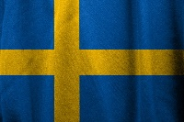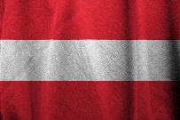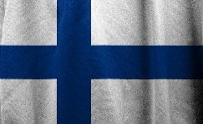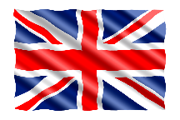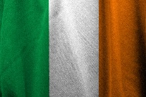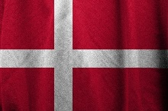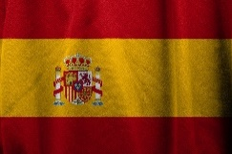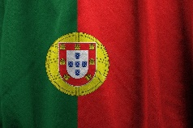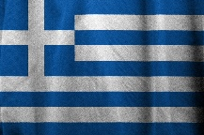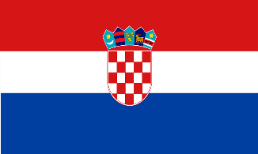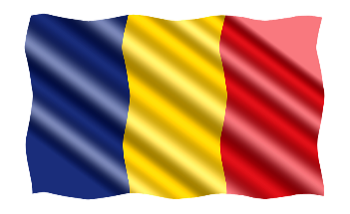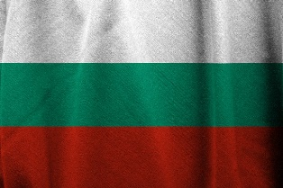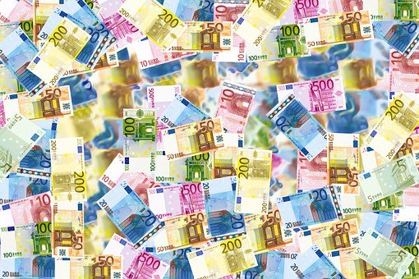

In 2007 the EU was enlarged with Bulgaria and Romania

2013 Croatia joined the EU so that the EU was enlarged to 28 member states

In 2004, the EU completed ist biggest enlargement by welcoming 10 new Member States

The Euro was introduced as cash on 1 January 2002

Finland, Austria and Sweden joined the Community in 1995

On 1 November 1993 the European Single Market began

In 1991, the Heads of State and Government oft he EC decided on the European internal market

1986 Accession of Portugal and Spain

1981 Accession Greece

Denmark, Great Britain and Ireland joined the Community in 1973

In 1951 France, Italy, Belgium, Luxembourg, the Netherlands and the Federal Republic of Germany founded the European Coal and Steel Community

The European Community was founded on 25 March 1957