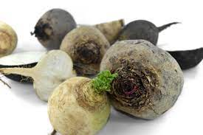
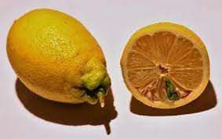
Determination of the vitamin C content

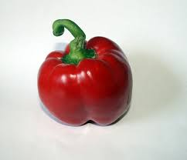
Redox titration is a method for determining the concentration. The substance to be determined (ascorbic acid/ vitamin C) is mixed with an oxidising (potassium iodate) measuring solution until the substance is completely oxidised. The excess of the measuring solution or the disappearance of the substance as the end of the titration must now be detected by a colour reaction. If there is an excess of potassium iodate, iodine is formed which is detected by the black-violet iodine-starch complex.
Ascorbic acid (AsH2) is thus oxidised and potassium iodate (KIO) is reduced.

Oxidation: AsH₂ As + 2 H⁺ + 2 e⁻
Reduktion: IO₃⁻ + 6 H⁺ + 6 e⁻ I⁻ + 3 H₂O

If all the ascorbic acid has been oxidised, the now excess potassium iodate reacts with the reaction product iodide, to form iodine. Iodine is detected by the black-violet iodine-starch complex.
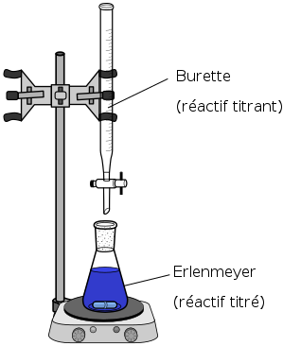
IO₃⁻ + 5 I⁻ + 6 H⁺ 3 I₂ + 3 H₂O

Experiment: Redox titration

Equipment and chemicals:
Kaliumiodatlösung
Tripod, burette clamp, burette, funnel, beaker, Erlenmeyer flask, mixer, press, kitchen towel, filter paper, potassium iodate (c= 0.0333 mol/l / 7.13gKIO₃ in 0.5l dist. water), starch (w = 10% in water / 1g in 10ml dist. water), sulphuric acid (c = 2 mol/l), potassium iodide (c = 2 mol/l / 3.32g in 10ml dist. water / prepare fresh).
Tomatoes, radish, lemons, peppers

Procedure:
1. Prepare chemical solutions. Prepare the potassium iodide solution only after the juice has been extracted.
2.Fill the burette with 10 ml of potassium iodate solution (make sure the tap is closed).
3. Prepare 50ml of juice of the vegetables to be tested by pressing, grating or mixing and filtering. For comparison, boil 50ml of lemon juice and use one day old squeezed lemon juice.
4. Put 50ml of juice, 1.5ml of the dissolved starch, 2ml of the potassium iodide solution and 5ml of sulphuric acid into the Erlenmeyer flask.
5. Now slowly add the potassium iodate solution from the burette and swirl the juice mixture (possibly with a magnetic stirrer) until the solution changes colour permanently.
6. Read off the volume of the used potassium iodate solution.

Task: Calculate the mass concentration of ascorbic acid

m (g) = (17.6 ml / 1000) x ml consumed iodate solution

