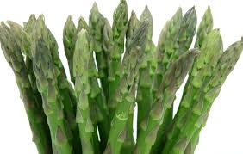
Urine smell after asparagus meal

Spring is finally here again, the asparagus season begins. This is also noticeable in the toilet. It stinks of asparagus urine. Let's get to the bottom of the smell. How does it develop, what interesting scientific findings are there about the smell of asparagus?
Task 1: The first information you get is that the excretion of the smelly asparagus urine is inherited. Find out whether this is a dominantly or recessively inherited autosomal characteristic and justify this using the family tree. Add the genotypes of persons 1-12.
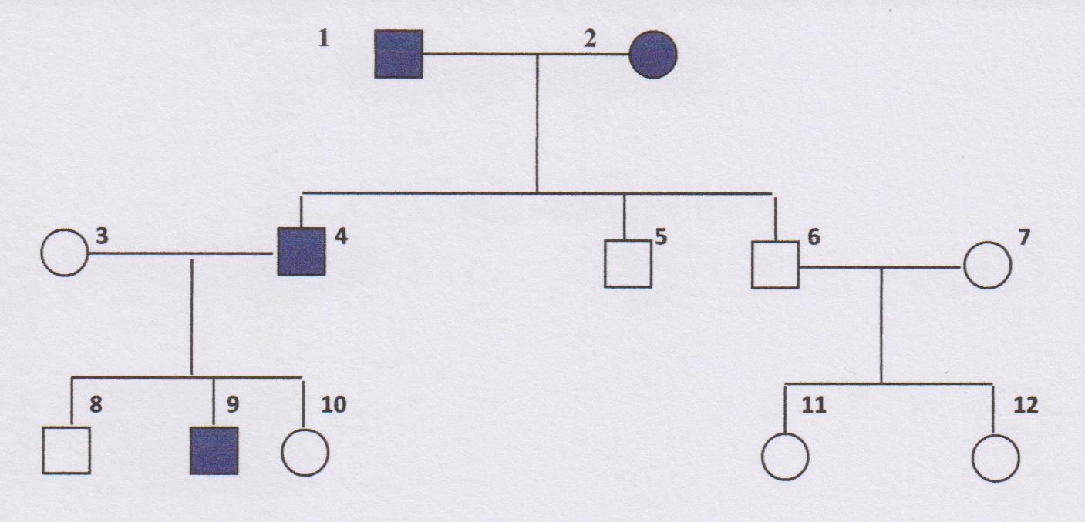
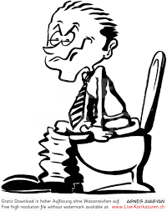

Task 2
Give reasons for the probability that a child of persons 3 and 4 will have a smelly urine. Draw up a crossbreeding diagram for each of the possible hereditary traits.
Task 3
- Research why the urine smells bad.
- Write down the substances that determine the smell and try to write down the chemical formula of one of them. Also draw the chemical formula of asparagusin acid and name and label the functional group. Here you will also find out whether you were correct in task 1, i.e. how the production of urine smell is inherited.
- Name traditional asparagus varieties and the difference between white and green asparagus.
- In 2010, further research results were obtained. What is anosmia? For fast workers: Why is the smell of sulphurous substances important in the developement of mankind? Use the internet pages to find out:
https://www.spektrum.de/frage/warum-hat-der-urin-nach-einer-spargelmahlzeit-so-einen-merkwuerdigen-geruch/618778
https://www.dasgehirn.info/aktuell/neues-aus-den-instituten/wenn-man-die-gefahr-riechen-kann

