First aid box and injuries vocabulary

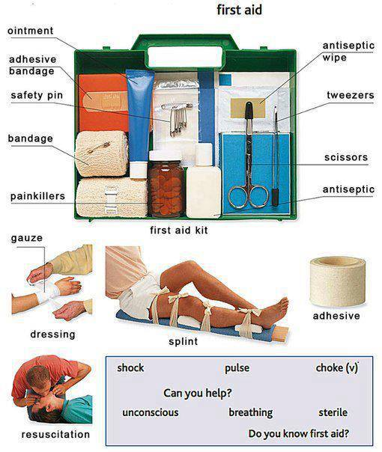

What to say if someone is injured ? (you)
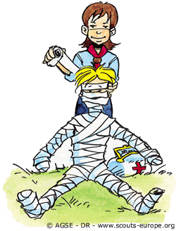
Where does it hurt?
Can you show me where it hurts?
Are you OK ?
Let me help you
Can I help you, am trained in first aid

If the person is in too much pain
If you can help them, treat them till an ambulance or doctor arrives
If you can not help, call an ambulance

What a person who is injured might say (he/she)
Can you help me?
I have pain in my leg / arm / chest ext.
My leg is hurting, my arm is hurting ext.
Do you know first aid?
I need to go to hospital.

Types of injuries

http://www.passporttoenglish.com/Advanced-English/Lesson12/Vocabulary.html
http://www.englishexercises.org/makeagame/viewgame.asp?id=5456
http://www.michellehenry.fr/first_aid.htm

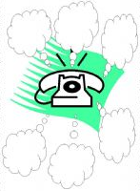 | Emergency !  Which numbers do you have to call ?  - FRANCE :  15 (MEDICAL EMERGENCY)  18 (FIREMEN)  17 (POLICE)  - Someone who don’t speak French :  112  - EUROPE :  112

