WHAT A WONDERFUL WORLD

During the lesson, the teacher talked about the difficult time Europe is going through. The teacher explained the most important moments in recent local history and showed how compromises were made to live in peace. This topic was explained because a wonderful world cannot exist without peace.

Subsequently, attention was given to the naturalistic aspect of our area, with the mountains and the Dolomites in particular, that are UNESCO World Heritage.

Then all the students wrote on a poster what they think makes the world wonderful…

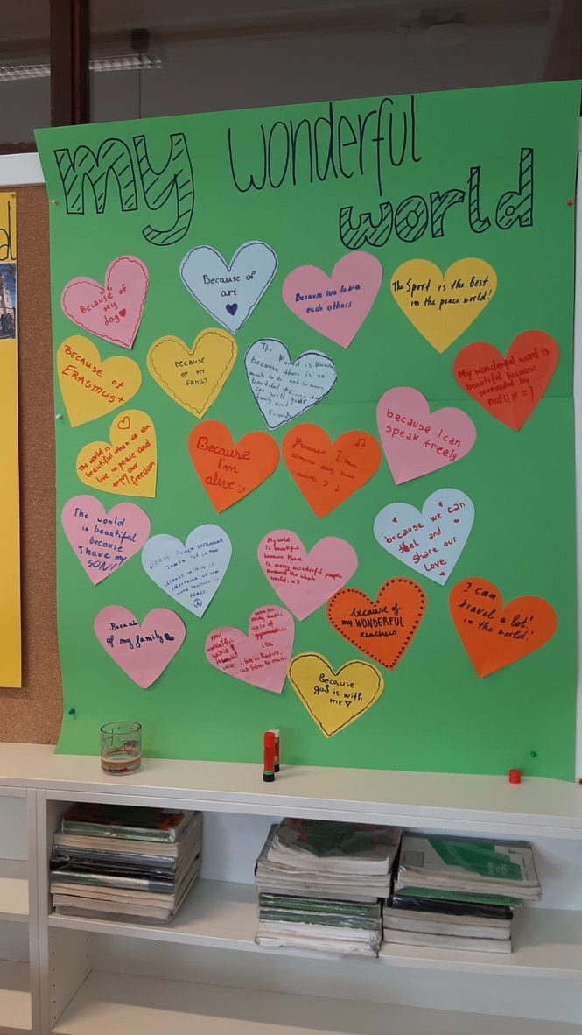
Afterwards, a film created by a class of the middle school of Olang was shown (about the task topic).

Finally, each delegation presented to the others (with the help of a computer and a projector) something special about their country, something they thought made their own country wonderful.

The purpose of this lesson was to reflect on the beautiful things we have near and far from us and to understand that with respect and peace we too can create a WONDERFUL WORLD.

