GENERATORY KODÓW QR
Links to the generators:
https://www.qr-online.pl/
http://mal-den-code.de/
QR codes:
- allow you to write a lot of data on a small space,
- make lessons more attractive,
- encourage students to active work,
- are a mixture of mistery, good fun and effective learning.
Lesson preparation with QR codes:
- write down the tasks on
qr-online.pl and print the generated codes,
- write a short feedback on mal-den-code.de and print generated codes to colour by students during the work with coded tasks.

Marzena Węgiełek’s examples of work with QR codes:

Grade 4:

Great! (1 – 6)
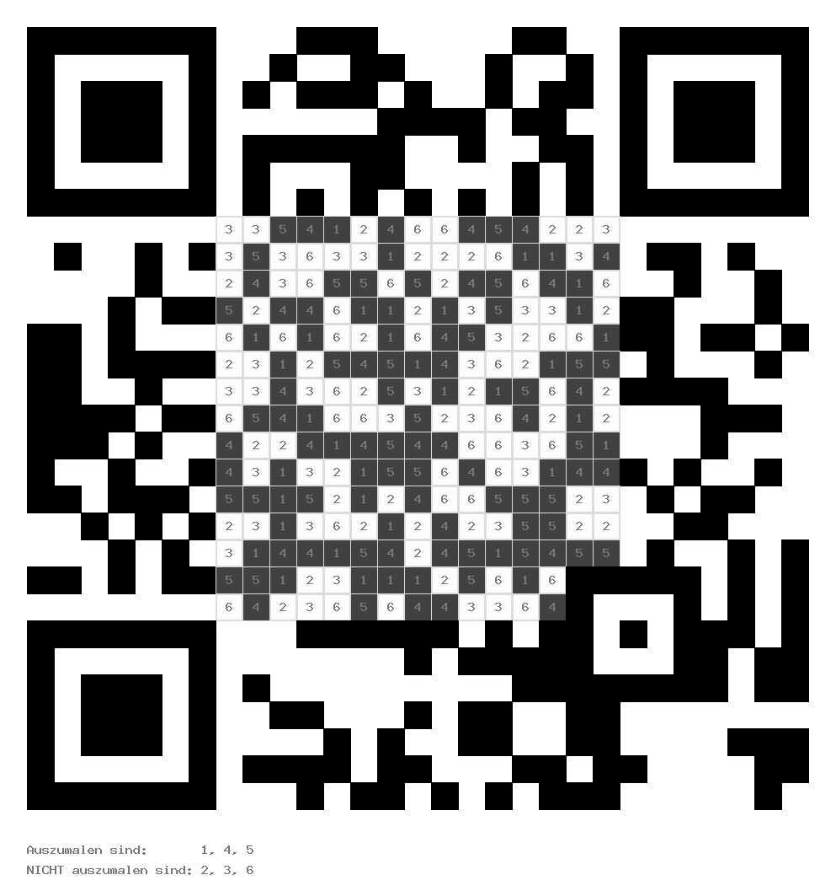
- The train from Warsaw arrives to Gdańsk at 23.38. What time should it be in Gdańsk if it’s delayed by 35 minutes?

- 00:13 (colour all 1 black)
- 23:03 (colour all 2 black)

2. A number XXIV written in Arabic digits is:
- 26 (colour all 3 black)
- 24 (colours all 4 black)

3. Staś has got 150 20groszy coins. How much money has he got?
- 30PLN (colour all 5 black)
- 300PLN (colour all 6 black)

