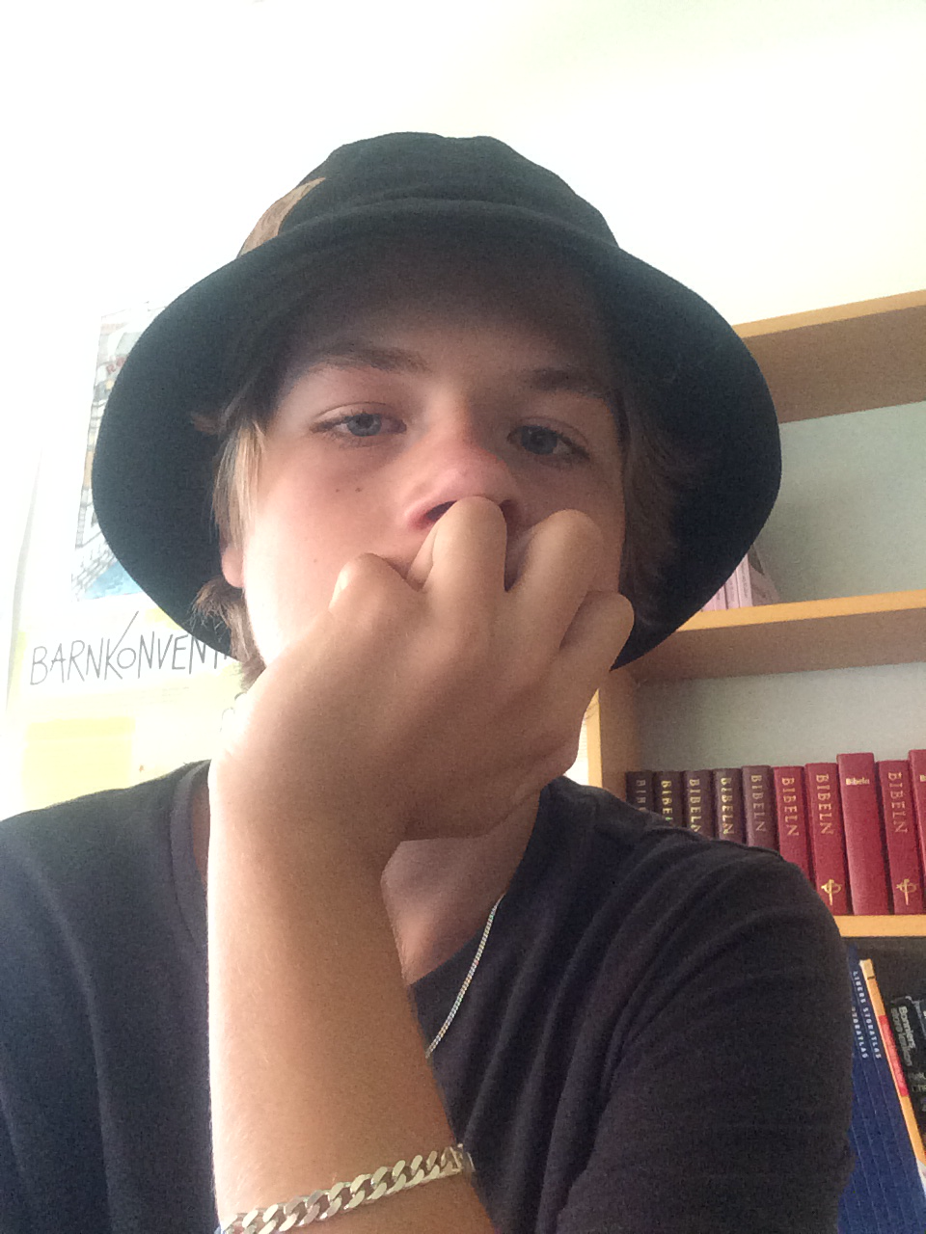
My name is Hannes and i live in Onsala. My favourite subject in school is mathematics and PE. When i grow up i want to be a dentist. My favourite food is tacos or pancakes.

