I. STATUE DESCRIPTION (photos, videos, maps, text)

1. . Show the photograph of the statue!
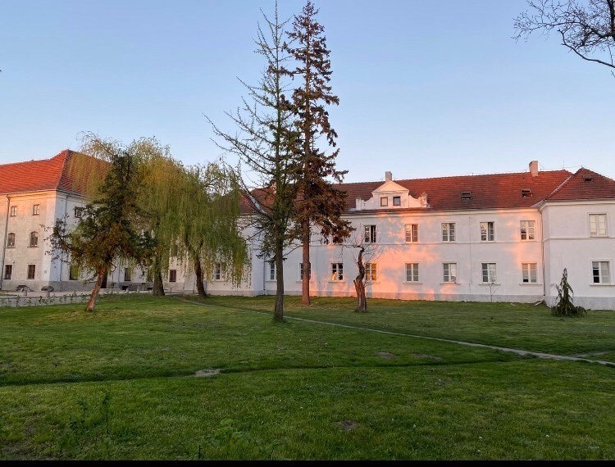

2. Show the position of the statue on the map! Add an interactive link form Google Maps (if it exists) or drop a new pin, print screen and add print screen! 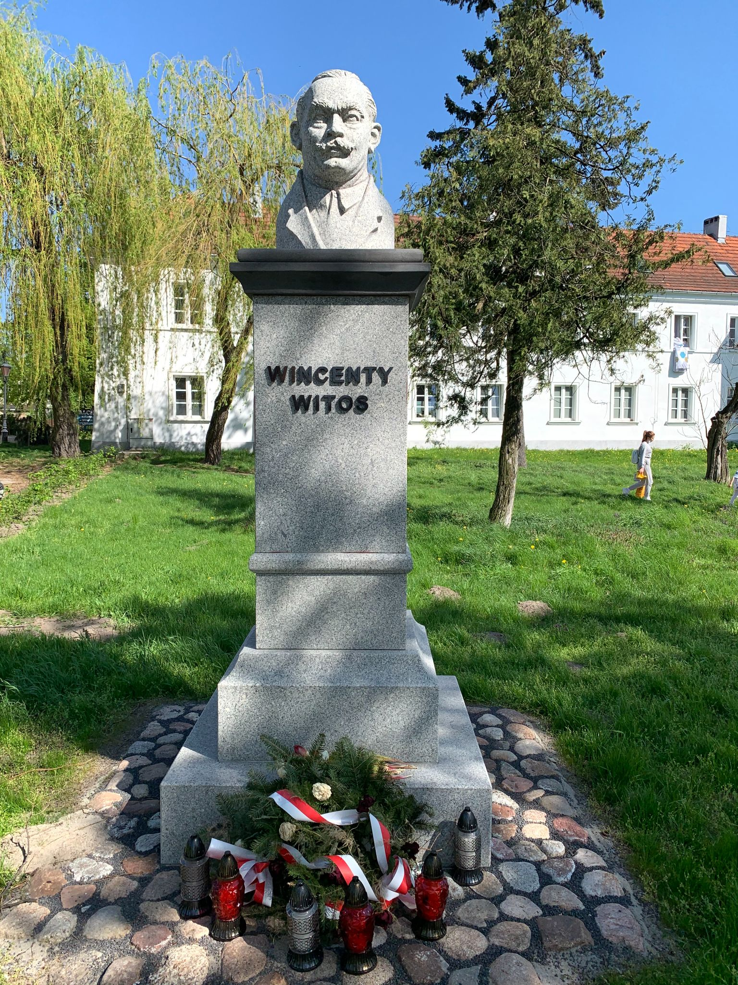

3. Show the surroundings of the statue with a photograph or a short video!

4. Describe the location of the statue! Who can see it there?

This monument is located at Stanisława Stanisławskiego Street in Łowicz. All passers-by can see it.

5. Who is the author of the statue? What are the most important information about the sculptor?

It was created on the initiative of members of the "Dom Ludowy" Society in Łowicz.

6. What is the style (artistic/historical…) of the statue? Is there something you like /don’t like about the style?

This statue has a realistic style and we think it’s very cool

II. 3D MODELS OF STATUES

1. Show the animation with the link to the video! 3DF Model Video name: WK NR Name of Statue.mp4 (youtube)

2. How many 3D photos did you try to use for making the 3D Model of your statue? 3. How many 3D photos were used for making the 3D Model?

We tried to use 45 photos to make this 3D model, but in the end we only used 44.

4. Is the surface of the 3D Model completely closed?

Yes

5. Were there any issues when using the 3DF Zephyr? Is the software user friendly? III.

There weren’t any problems. The software was very user friendly.

DESCRIBING THE PORTRAYED PERSON

1. Who was the person that this statue is dedicated to?

Wincenty Witos was a Polish politician, prominent member and leader of the Polish People’s Party, who served three times as the Prime Minister of Poland in the 1920s.

2. When did he/she live?

He lived between 1874 and 1945

3. What were the circumstances?

Wincenty was born in a family in Wierzchosławice in Lesser Poland. His parents were Wojciech and Katarzyna. The family was poor, owning little land and no livestock and they lived in a single room hut. Wincenty had two brothers, Jan and Andrzej. Andrzej would also become a leader in the Polish agrarian movement.

4. What was his/her job?

He was a Polish politician and member of the Polish People Party. He also has served three times as the premier of Poland.

5. Describe his/her work in short!

He started out as a memeber

6. Was this person famous and recognized in his/her lifetime? (Why not?)
7. What did he/she do to deserve a statue in his/her honour?
In the Reborn Poland, Witos was prime minister three times. He took the helm of the National Defense Government for the first time in July 1920, at the time of the Bolshevik offensive and the deadly threat to the country. As the prime minister of this government, he issued a famous appeal to the people, calling them to support the defense of Poland.

8. Can his/her work in a certain field be inspiring or groundbreaking or world-changing?

