One extra colour

Last week, up among the clouds all colours started a new day. There were: red, orange, yellow, green, blue and violet. Suddenly they noticed indigo nearby.

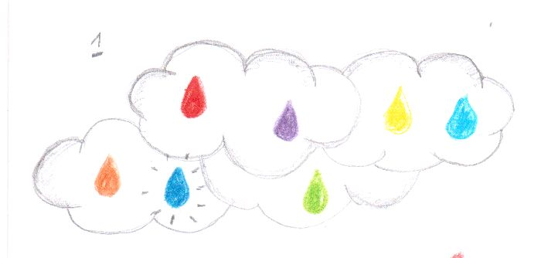

The colours did not know him. Indigo wanted to join other colours but they didn't agree. They even started kicking him...

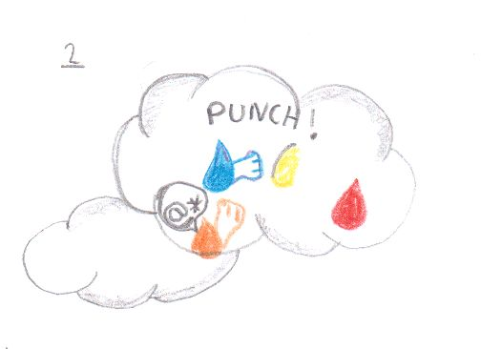

After a long discussion red, yellow and violet decided to invite indigo to the rainbow but other colours went on strike and met on the biggest cloud in the sky.
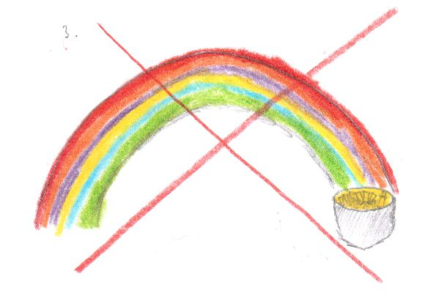

A view was beautiful! A big ocean was beneath. Soon red, violet and yellow appeared on the cloud. They insisted that their idea of inviting indigo was excellent. But plotters surrounded him and pushed indigo down to the ocean...
That is why sea water is indigo till nowadays.

By 5A

