Big Grey Cave and Tinter
Once upon a time, in the middle of nowhere, there was a Great Grey Valley with a Big Grey Cave. There was a mysterious Grey Chest in a Big Grey Cave. Nobody knew what was inside. Nobody was brave enough to open it.
It was believed that all colours had been closed there many, many years ago. That was why the world was grey and sad.
A little boy lived not far away from the cave. His name was Tinter and he really hated greyness he was forced to live in. He decided to do his best to make the world happier and more beautiful. One day he left his house and started his journey in search of colours.
by Julka T
Even if it was not a very long distance he did not want to walk quickly. He decided to learn more about the Big Grey Cave. He knew almost nothing. He went to a library and studied many old books.
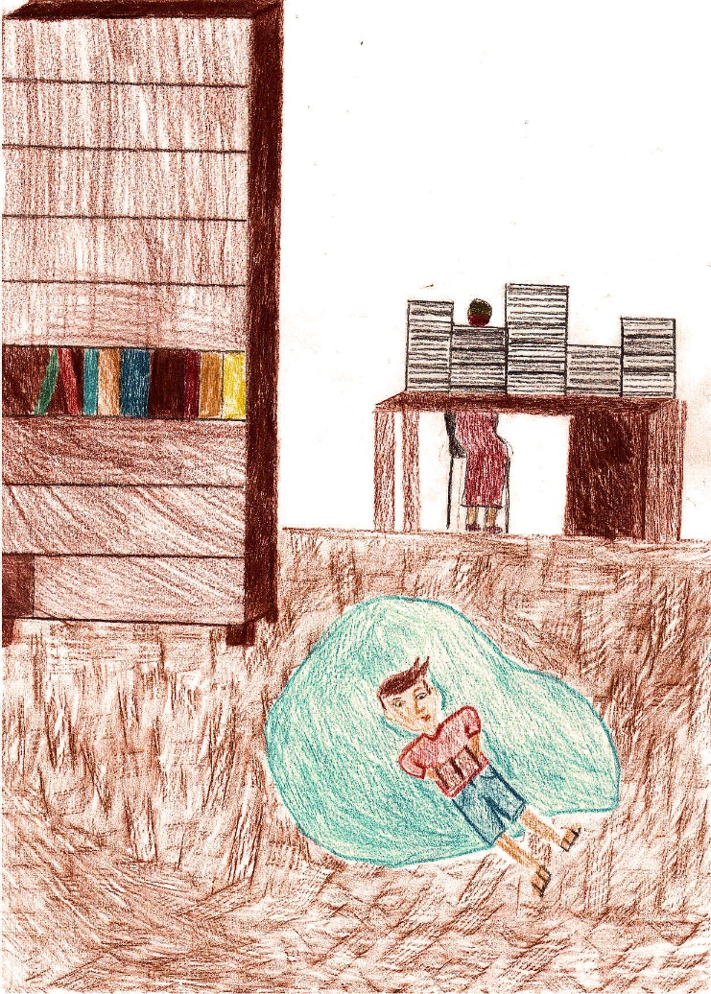
He also asked people about its mystery. It took him some time, he needed 5 years, 7 months, 20 days and 7 hours to reach the Great Grey Valley.
by Zosia H
As the time passed, he was not a little boy anymore. He was much taller and stronger. Looking at the valley he remembered all the information and legends he had found in books. One seemed to be the most interesting:
○ ○ ○ ○ ○
“A princess Celine loved all colours and felt happy. She smiled a lot and painted colourful pictures.
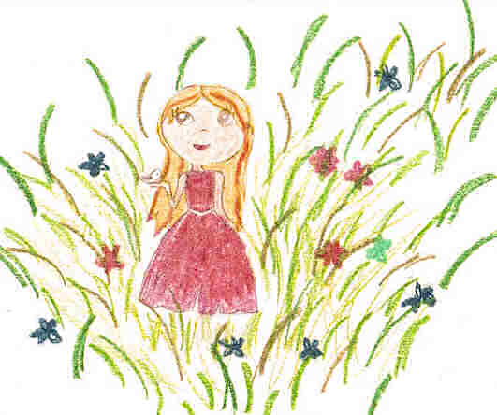
Her father was a despotic and cruel ruler. He didn’t like colours and hated people who smiled and were happy, even when it was his own daughter.
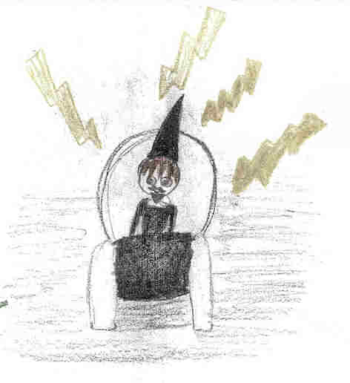
One day the king and the princess had a huge argument about Mysterious Colourful Key that was needed if the world was to be full of colours or not.
by Magda B
The princess got the key from her grandmother but her father wanted her to give it to him. She didn’t agree. She was afraid he would hide all the colours somewhere so that the world could be as sad as he was.
Celine decided to look for help. She went to the market place to meet a man who was a world famous specialist in map making and object hiding. The princess decided to give him the Mysterious Colourful Key.
He found a safe place for hiding it, drew a map and handed it to Celine. The world stayed colourful. Celine went to a forest and hid the map under an old oak tree.
by Nina
Years were passing by. Celine became older and decided to find the map and the Mysterious Colourful Key. She did as she had planned. With the key in her hand she went to the Great Valley and entered the Big Cave. She wanted to check if all colours were on their place, in the mysterious chest. She loved colours so much…
Suddenly somebody took the key away from Celine, locked the chest and run away. At that moment the chest went grey … and the world too… Celine burst into tears…”
○ ○ ○ ○ ○
Tinter didn’t forget the moving story. He was sitting on the grass close to a brook nearby the Big Grey Cave and tried to think what would be the best solution. Suddenly something shone in the water. It was a key but it was a grey one…
After having cleaned the key, it became clear to Tinter that he found Celine’s precious Mysterious Colourful Key! He needed the key so much! It was so fantastic!
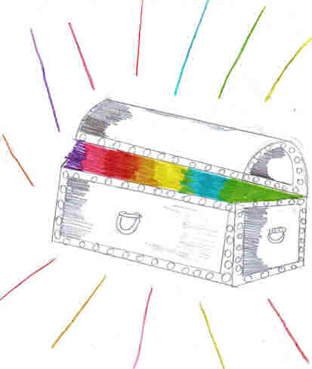
He immediately opened the Grey Chest and all the world became colourful. People felt happy and so did Tinter.
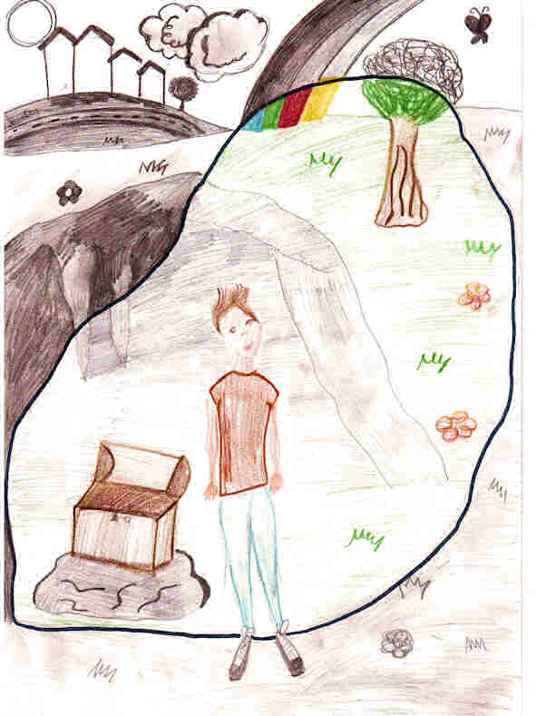
by Sonia

