Magic Sweets

It was a typical day at Victoria's school. All students were in classrooms. But teachers didn't come. Moreover, suddenly the school started losing colours. It was scary. Students came to the teachers' room. It was empty but they found a letter. There were puzzles in it. When the students solved the puzzles, a magic door opened. The students went through the door, they planned to look for the teachers but they found a book, the mysterious one. It was full of recipes. It wasn't that easy but the students found one recipe suitable for the situation, against greyness. They should mix all rainbow colours. It was no rainbow in the sky. They were waiting 10 days. When they woke up in the morning they saw a beautiful rainbow.

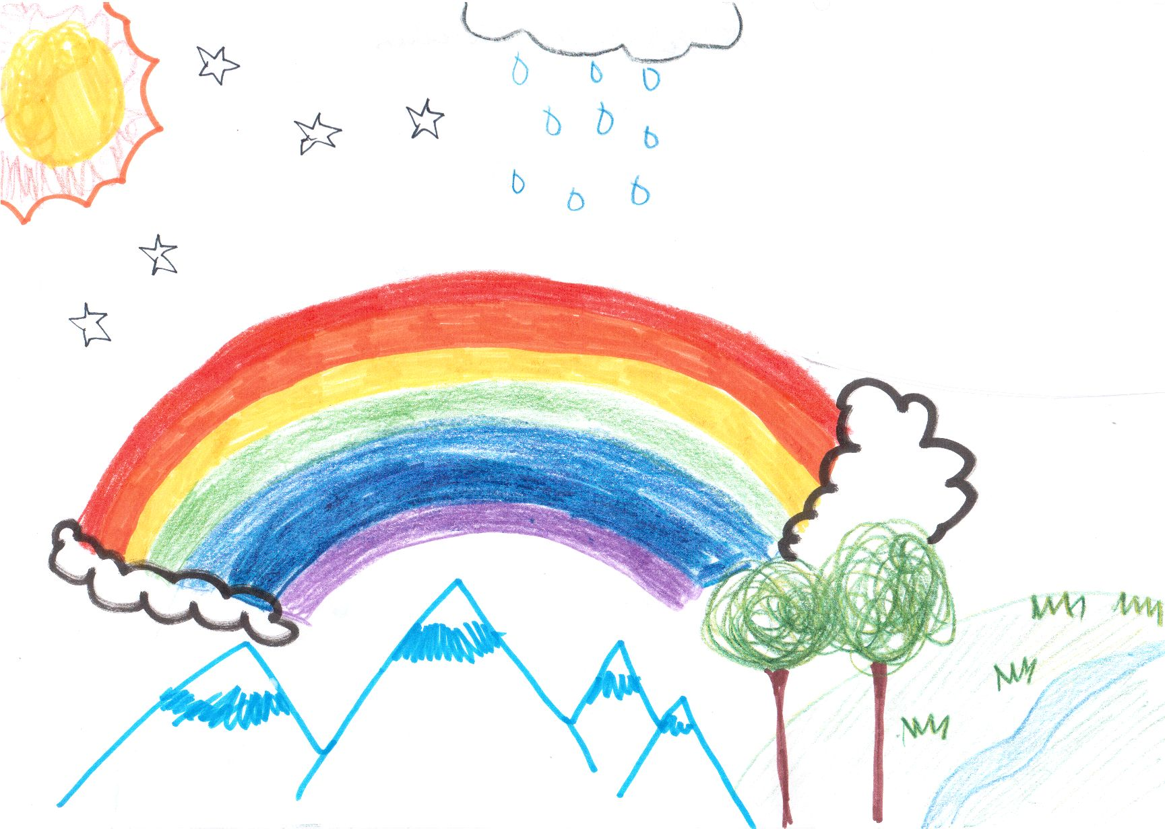

Students run to its end and at the place where the rainbow touched the ground there was the most colourful world you can imagine. They were happy, they thought the rainbow had brought colours back to the world. But they were wrong. Their school was colourless. They decided to make magic rainbow sweets. There was no other solution. They decided and did it. A moment they were eating the sweets all the world was getting more and more colourful. The next day all teachers came back to school, too. Students and teachers were happy they can live in a colourful world.

By 5B

