SMALL SCIENTISTS DISCOVERING THE SKY
LATVIA, LIEPAJA city
2nd experiment
NAIL POLISH RAINBOW
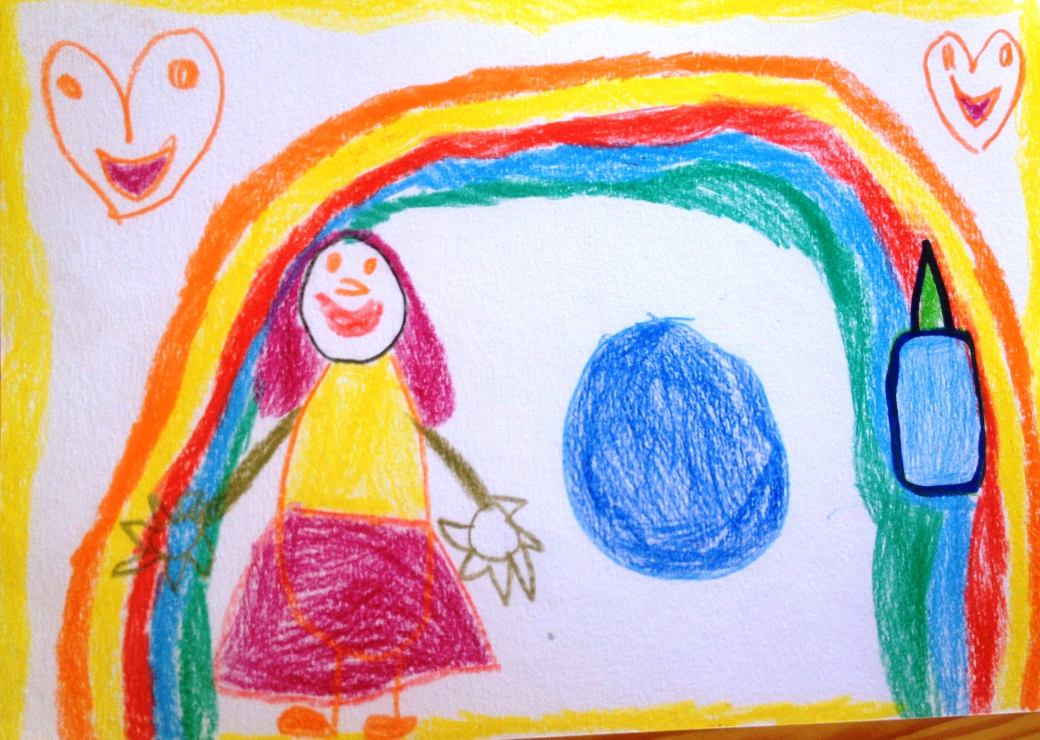
Author: Madara Skrube, 5 years

