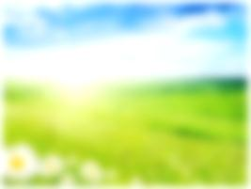
SMALL SCIENTISTS DISCOVERING THE SKY
LATVIA, LIEPAJA city
3rd experiment
SUN REFLECTION
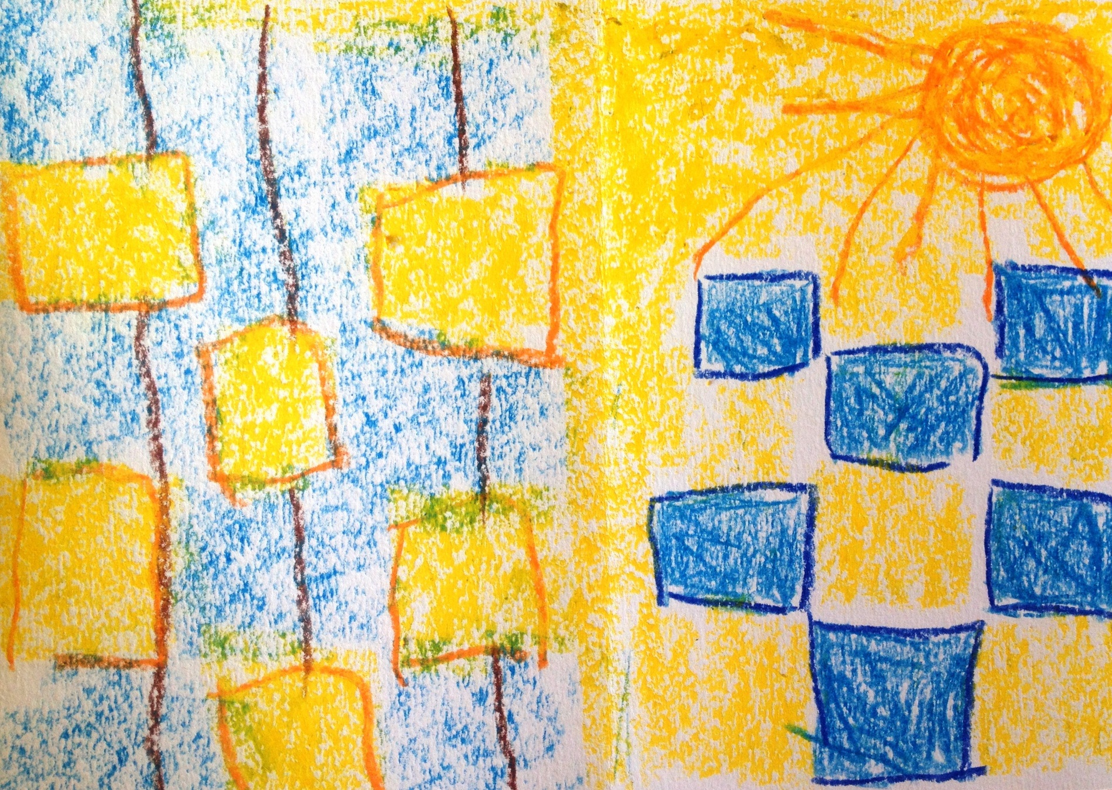
Author: Rebeka Niedre, 5 years

