SMALL SCIENTISTS DISCOVERING THE SKY
LATVIA, LIEPAJA city
1st experiment
PLANT UPGROWTH IN LIGHT AND DARK
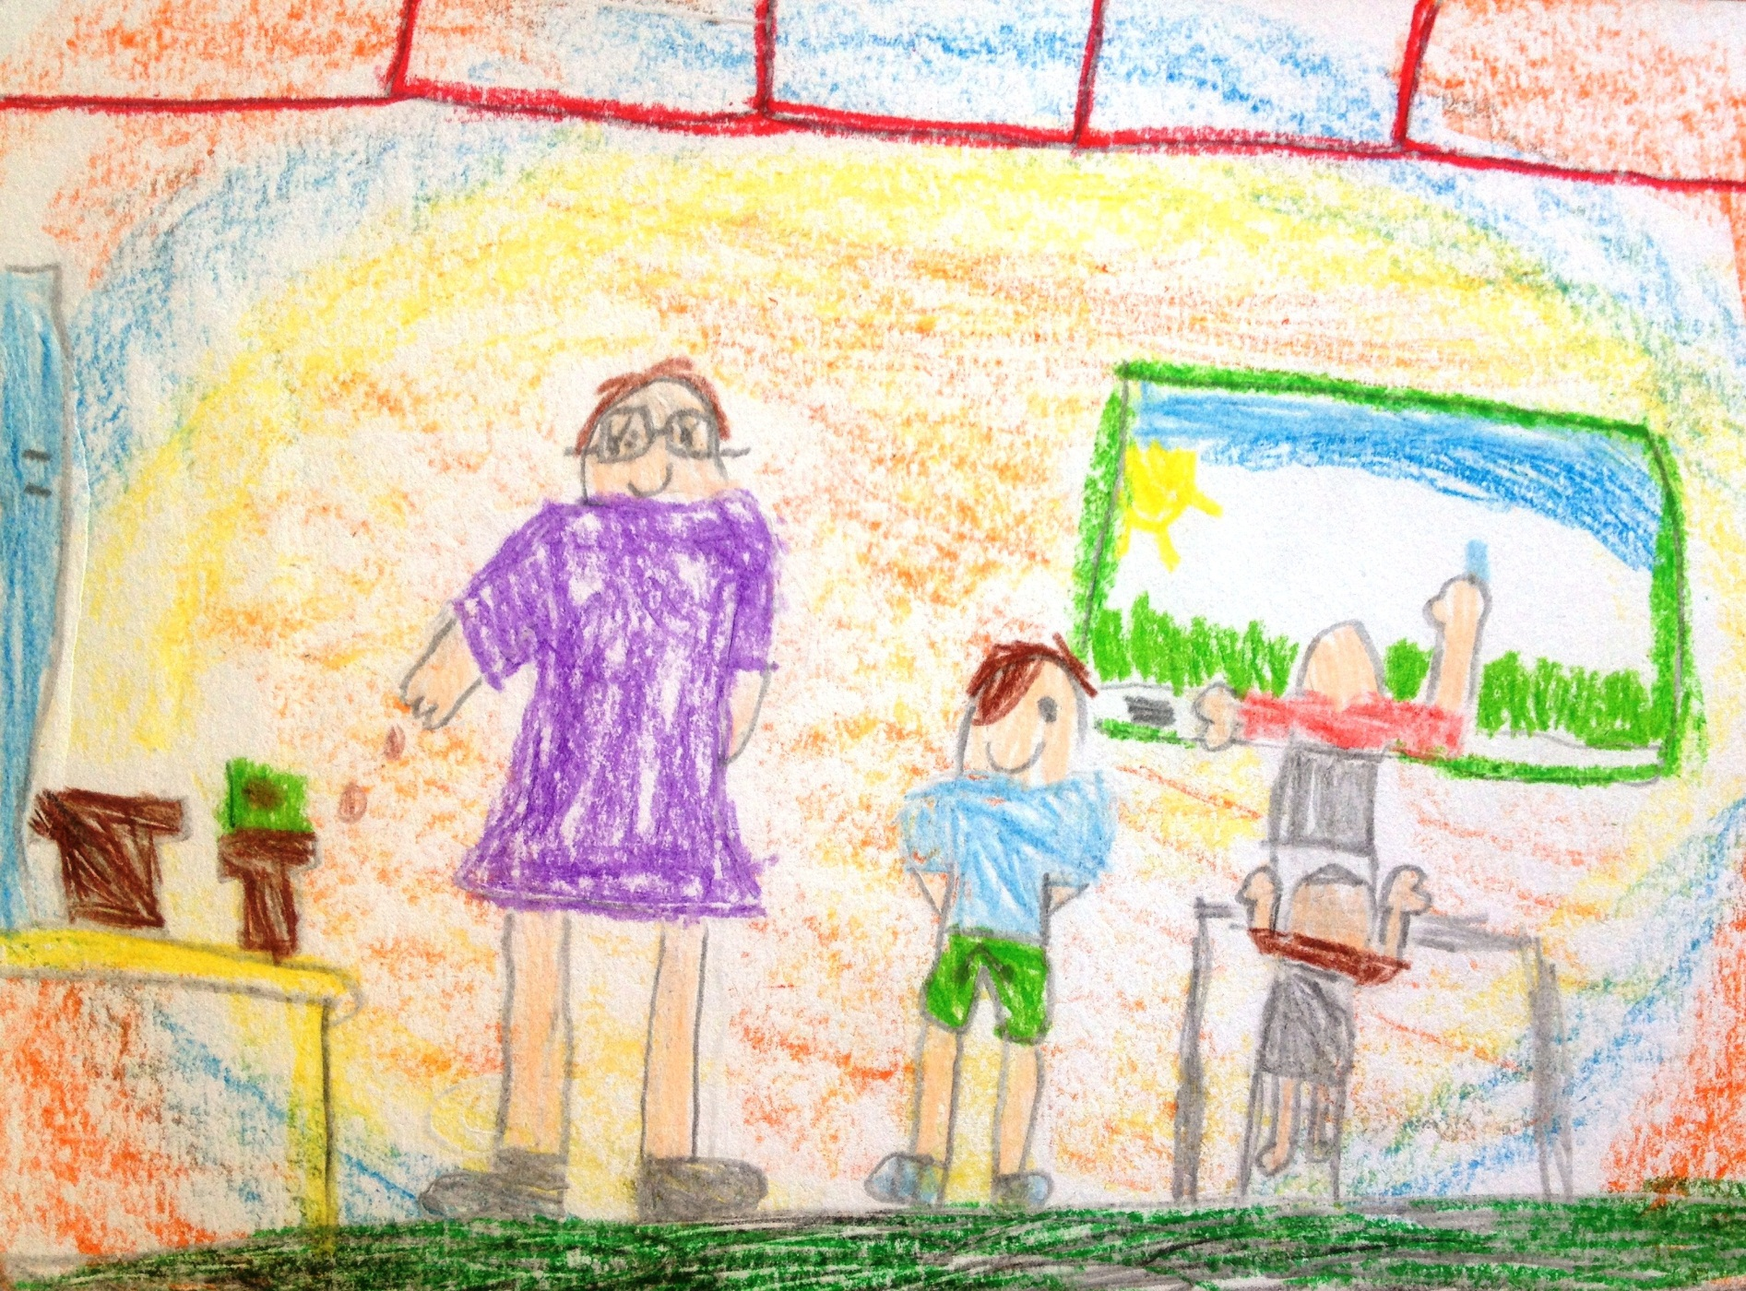
Author: Estere Preisa, 6 years

