SMALL SCIENTISTS DISCOVERING THE SKY
LATVIA, LIEPAJA city
6th experiment
CLOUD IN A BOTTLE

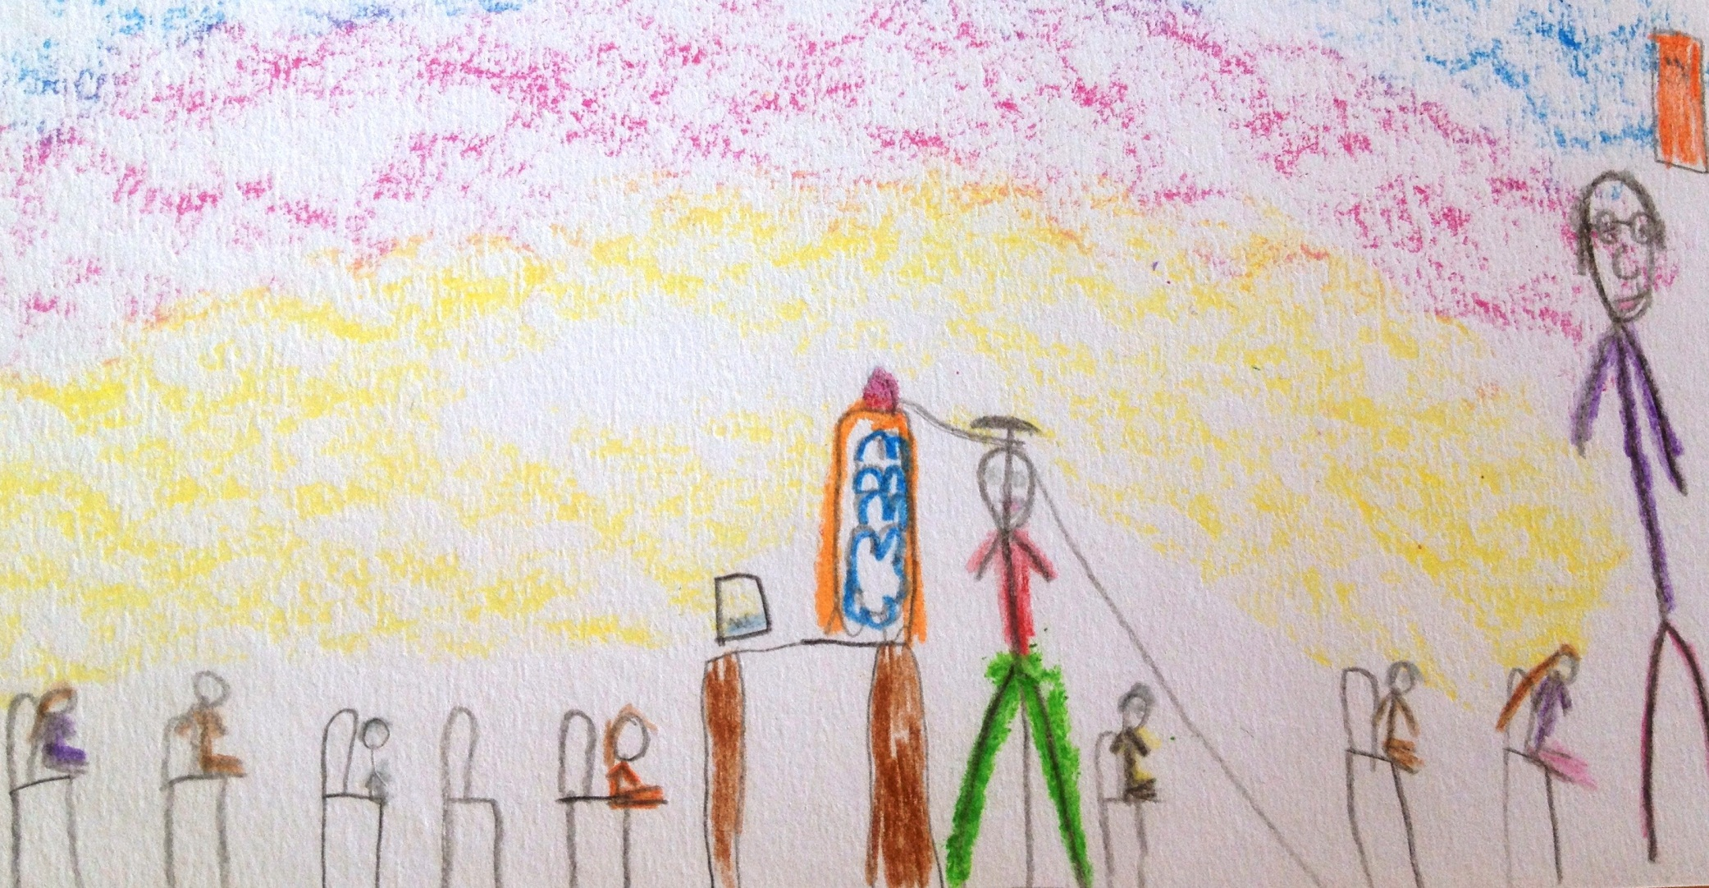
Author: Elza Neiburga, 6 years

