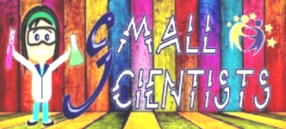
SMALL SCIENTISTS DISCOVERING THE SKY
LATVIA, LIEPAJA city
5th experiment
EVAPORATION & CONDENSATION
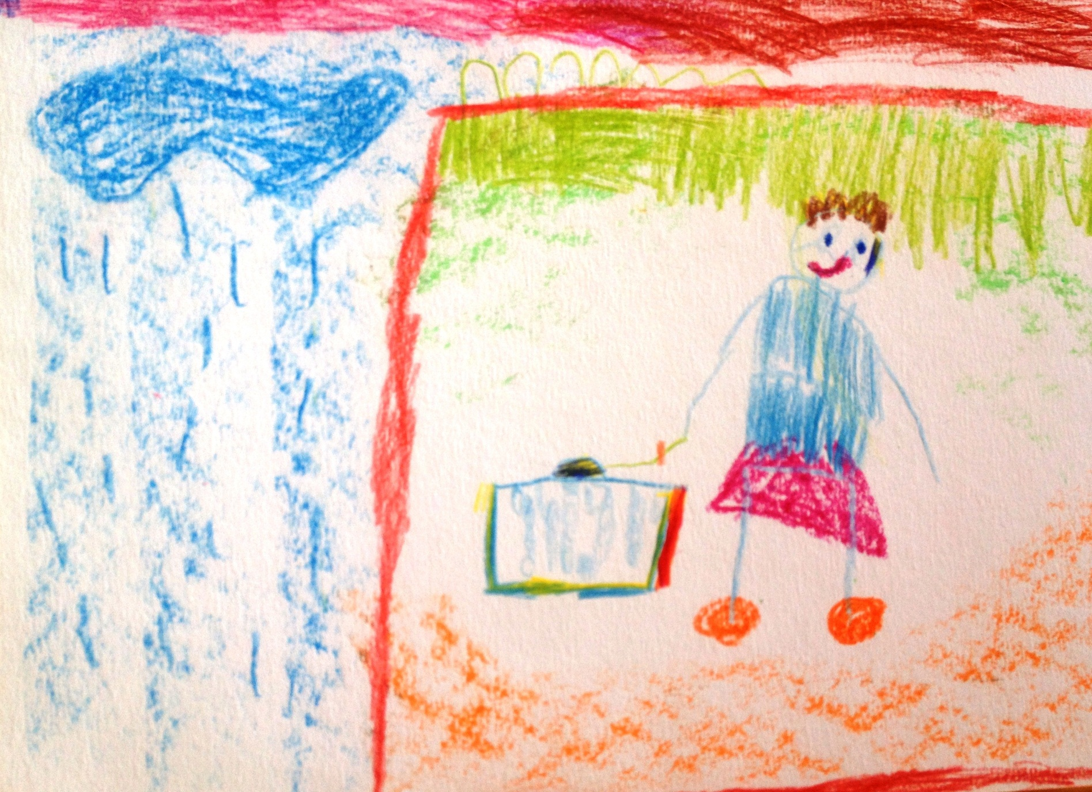
Author: Dominiks Liepiņš, 6 years

