SMALL SCIENTISTS DISCOVERING THE SKY
LATVIA, LIEPAJA city
4th experiment
AIR MOVEMENT IN NATURE
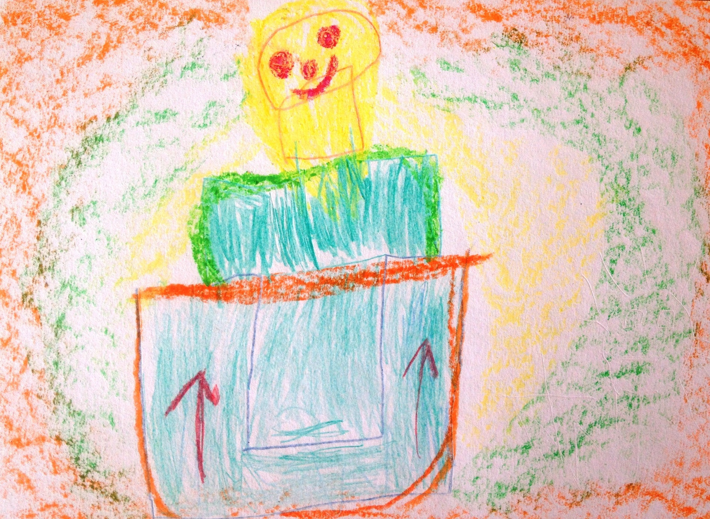
Author: Gustavs Rauls Daizis, 5 years

