EXPERIMENT 6: WATER, OIL AND DISH SOAP

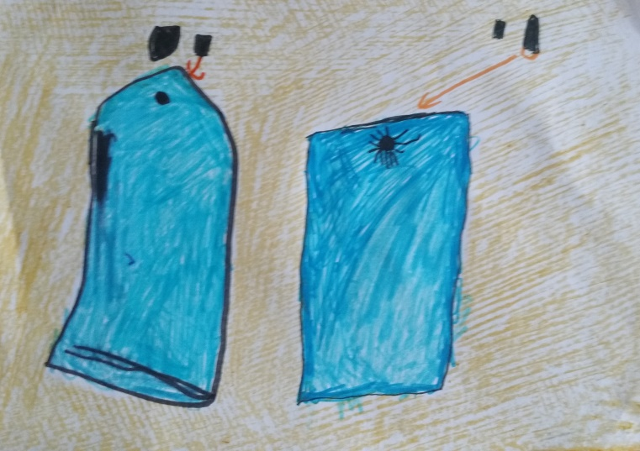
Emilė 5 years.

