EXPERIMENT 5: THE WATER EXPANDING

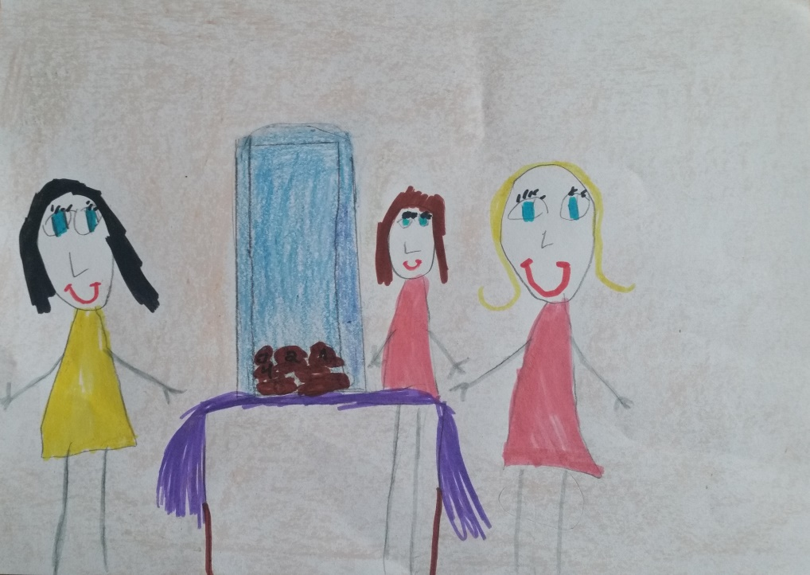
Rusnė 6 years

