EXPERIMENT 4: PAINTED FLOWERS

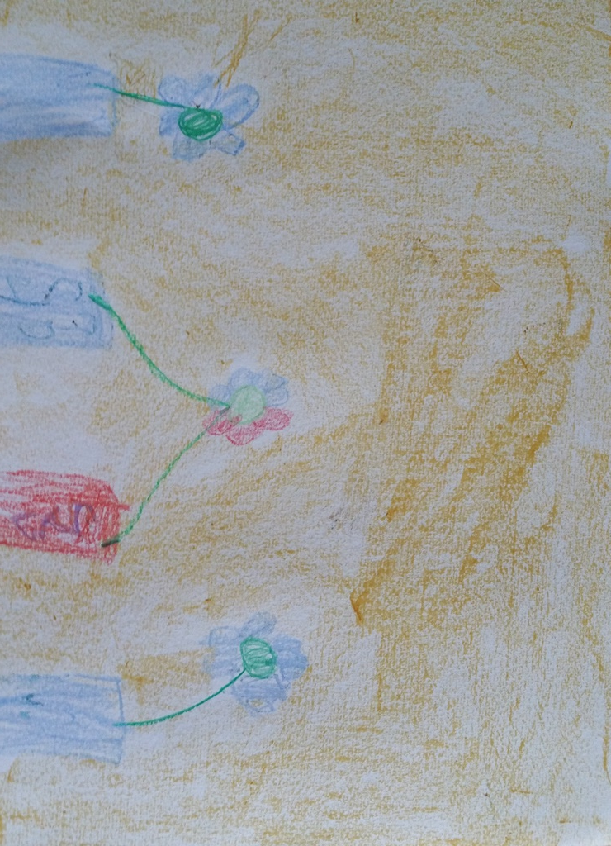 Eglė 6 years

