EXPERIMENT 1: HOW TO INFLATE A BALLOON WITHOUT AIR
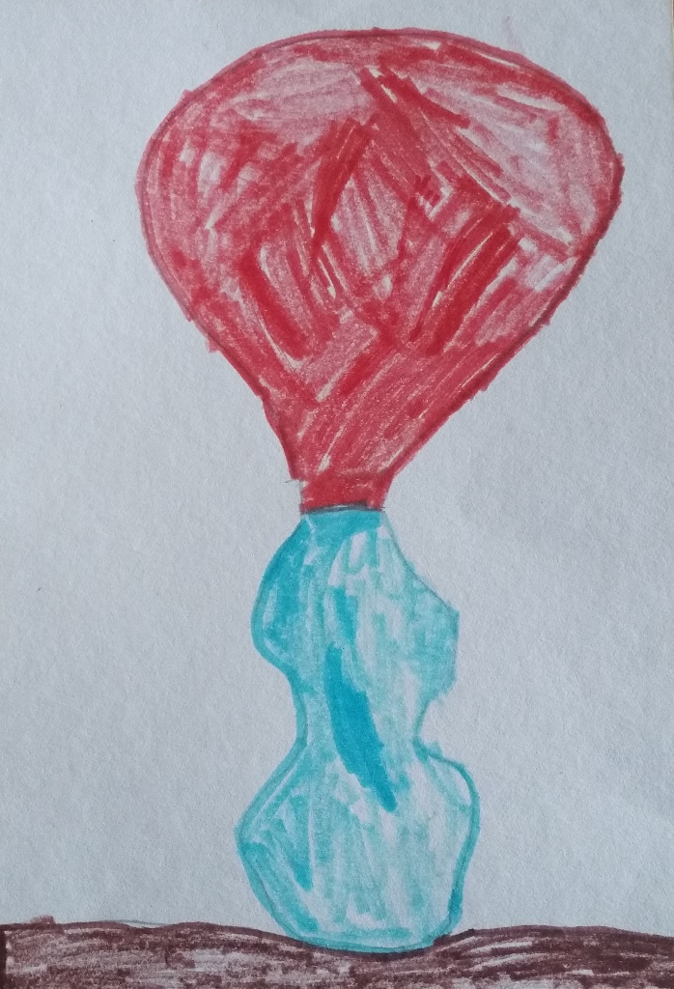

EVA 5 years.

