EXPERIMENT 3: THE AIR TAKES SOME PLACE
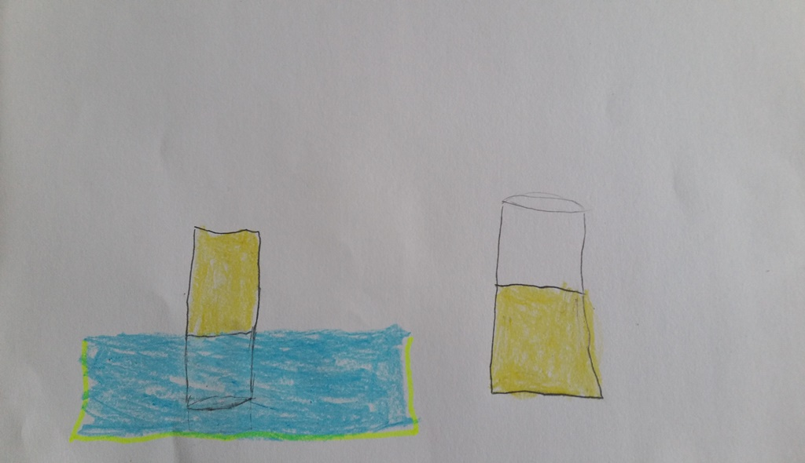
Martynas 6 years

