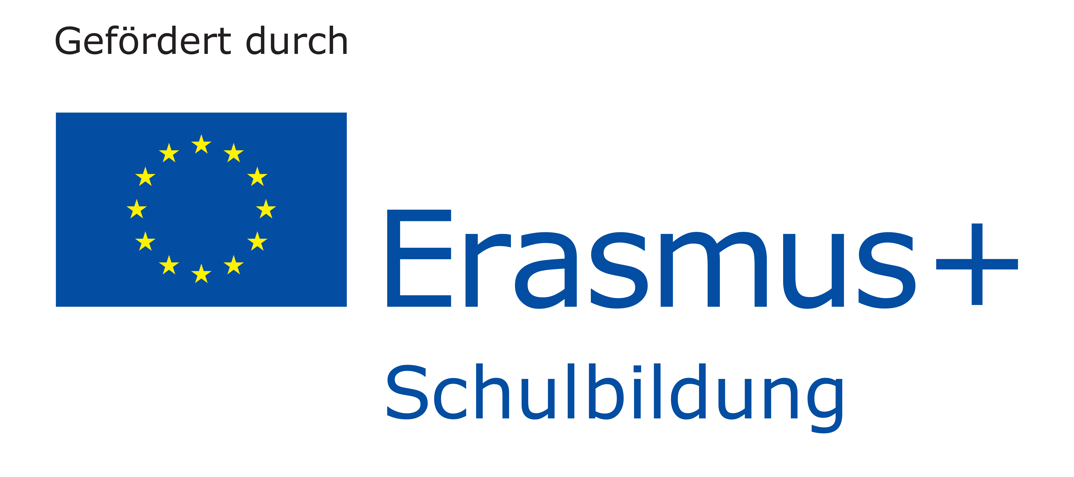
Certificate of Participation

awarded to

_________________________________________________________________________________________________________

for attending and actively participating in the 4th mobility of the Erasmus+ project:

„Fit für den europäischen Arbeitsmarkt mit Bewerbungstraining und Praktika“
„Job orientation and work experience in Europe“

held by „Gesamtschule Lohmar“
between the 9th and 14th of February 2020

__________________________________________________________
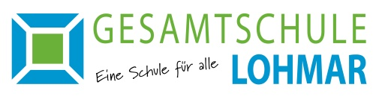
Uwe Spindler (Head of School)

