MATHS PLAN

COUNTRY: Turkey

SCHOOL : Erzurumlu İbrahim Hakkı Ortaokulu

ACTIVITY NAME: Speed measurement

MATERIALS: meter,different materials,clock to measure time(mobile is ok),paper,pen

ACTIVITY NUMBER: 3

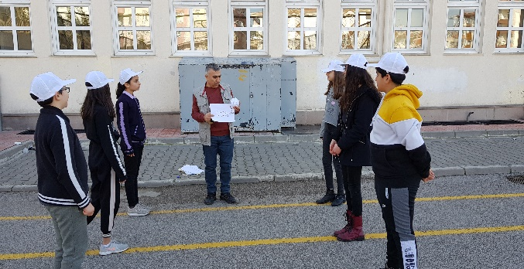
MAKING ACTIVITY:
Teacher will explain how to calculate speeds of different materials. In fact he will explain in a simple way as speed = distance/time.Its unit is m/s
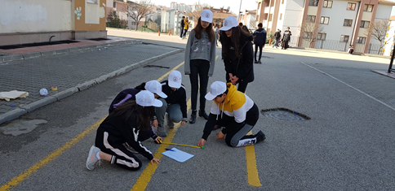
We will throw different materials to the ground and measure the distance between the point where it stops and line.Also we will record the time until it stops.Then we will divide distance in meters to time in secons.

PHOTOS:

