MATHS PLAN

COUNTRY: Turkey

SCHOOL : Erzurumlu İbrahim Hakkı Ortaokulu

ACTIVITY NAME: Volume measurement

MATERIALS: water,stone,graduated cylinder

ACTIVITY NUMBER: 4

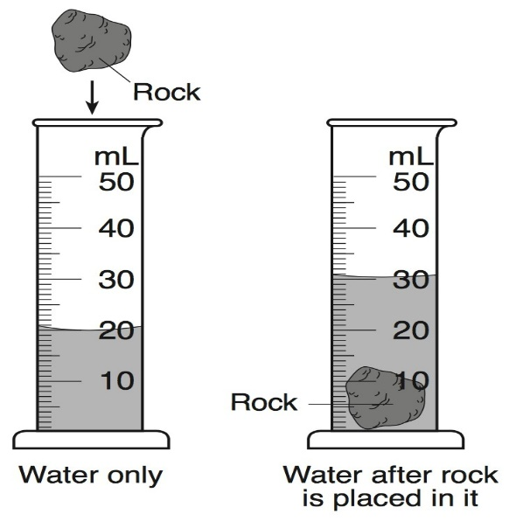
MAKING ACTIVITY:
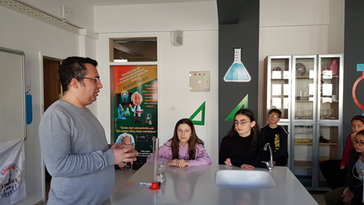
First Science teacher will explain the topic measuring volume of materials which have no definite shapes.
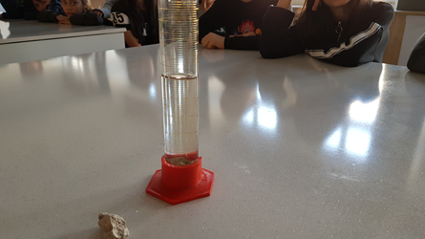
Then we will fill some water and thgen put a stone in the graduated cylinder,water level will increase .After that we will record the new level of water.Finaly we will subtract those values and we will find the volüme of our stone.
Volume of the stone:
V=30-20= 10 ml
V= 10 cm3

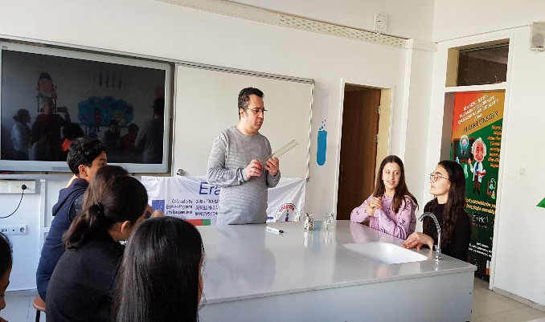
PHOTOS:
