MATHS PLAN

COUNTRY: Turkey

SCHOOL : Erzurumlu İbrahim Hakkı Ortaokulu

ACTIVITY NAME: Teaching aim with to

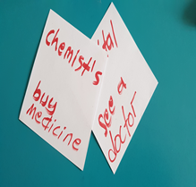
MATERIALS: Any kind of cube,small papers 6 pieces
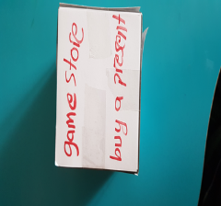

ACTIVITY NUMBER: 2

MAKING ACTIVITY:
First teacher will explain the topic to;
To Express our aims we use “infinitive to” for example;
I will go to the chemist’s to buy painkillers. Here to shows our aim.
Now we will play a game.I wrote some sentences on these small papers and sticked on each surface of the cube.You will make sentences to Express your aim ok?
Let’s start,say “ Throw the cube ………. times “
Pupils: Sir,throw the cube 3 times
Teacher: He throws the cube 3 times and pupils make the sentence with the words on top of the surface.
It writes “ coffee shop – drink coffee
One of pupil: I will go to the coffee to drink coffee.
Another pupil: Let’s go to the coffee shop to drink coffee.
Another one: Do you go to the coffee shop to drink coffee?
And then teacher quits from the activity.Pupils do this activity with their friends.
PHOTOS:
