MATHS PLAN

COUNTRY: Turkey

SCHOOL : Erzurumlu İbrahim Hakkı Ortaokulu

ACTIVITY NUMBER: 1

ACTIVITY NAME: Measuring distance on a map

MATERIALS: Map,ruler

MAKING ACTIVITY:

To calculate the distance between two points on a map,first measure the distance in cm between two points.
Let’s say the distance is 8 cm.Between City A and City B.
Then we we have to know the scale of the map.Let’s say the scale is;
1/50000
Then multiply the distance between two cities by the scale on the map.
8 cm X 50000 = 400 000 cm
The answer above now needs to be converted to the unit of distance in reality e.g. kilometres (km).
so we divide 400 000 by 100 000 then the distance between City A and City B is:
400 000/100 000 = 4 km.
Summary
To calculate distance on a map you must do the following:

Measure distance between two points on a map in cm or mm.
Multiply this by the scale of the map and divide by 100 000 if you used centimetres or by 1000 000 if you used millimetres to get kilometres.
Should the distance be required in metres, then you will divide centimetres by 100 or millimetres by 1000 according to the following table.
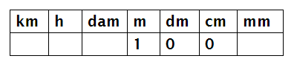

1m = 100 cm
4. Sometimes distance can be calculated along a winding river or path, this you
* do by using a piece of a string placed along the winding object and thereafter
* stretch it along the units of your ruler to determine the length and then
* calculate as shown in the previous steps.
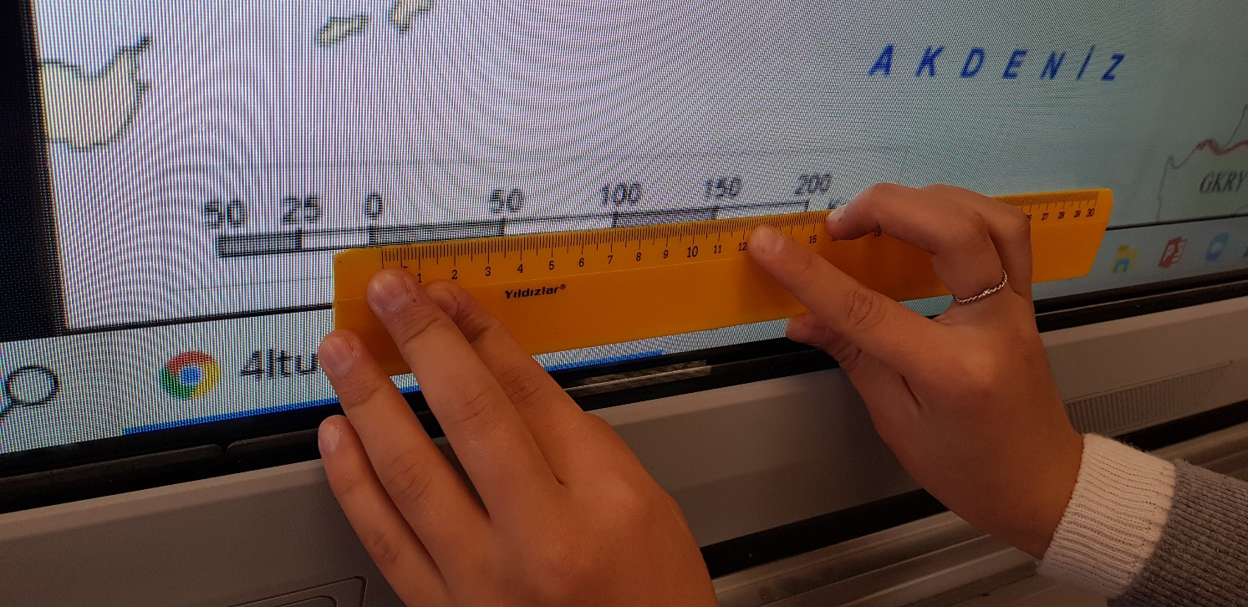
PHOTOS:

