ERASMUS+ KA229 2018-2020 PROJECT PARTNERSHIP
“ DEVELOPING AND IMPLEMENTING NEW STRATEGIES IN MATHS CONNECTED CURRICULAR SUBJECTS “
Initial Maths Test
Circle the correct option
1) The internal angles of a square each measure how many degrees?
A) 60 B) 90 C) 180 D) 360
2) How many points are there on a pentagon?
A) 2 B) 3 C) 4 D) 5
3) The distance from the center of a circle to its edge is called what?
A) diameter B) radius C) height D)
4) What is this shape?
A) triangle B) parallelogram C) trapezium D) circle

5) What is the fraction value of 0.8 decimal value?
A) 4/5 B) 1/4 C) 3/6 D) 5/12
6) All sides of a scalene triangle have the same length.
A) scalene B) isosceles C) equilateral D) none
7) A concave shape bends ____________.
A) outwards B) downwards C) upwards D) inwards
8) Which one is smaller?
A) 1/10 B) 1/100 C) 1/1000 D) 1/10000
9) How many triangular faces does a square pyramid have?
A) 6 B) 5 C) 4 D) 3
10) What is the next prime number after 7?
A) 11 B) 9 C) 7 D) 8
11) Which of these numbers is not an integer?
A) 1/ 2 B) 0 C) 100 D) -2
12) What comes next in the Fibonacci sequence: 0, 1, 1, 2, 3, 5, 8, 13, __?
A) 14 B) 21 C) 15 D) 17

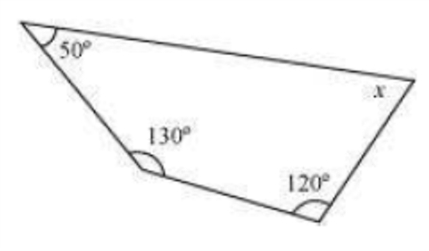
13) What is the angle measure X?
A) 120 B) 180 C) 360 D) 60

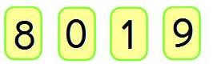
14) What is the largest 4 digit number that you can make using these cards?
A) 8901 B) 8910 C) 9801 D) 9810

15) Which line correctly shows the line of symmetry for the butterfly?
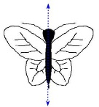
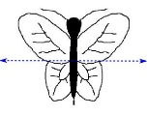
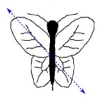
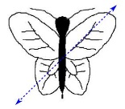
A)
B) C) D)

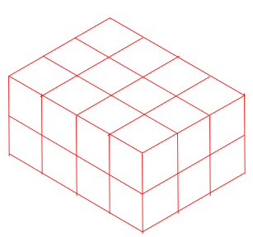
16) Use the formula V = l × w × h to find the volume of the cuboid.
What is the volume of the cuboid?
A) 14 B) 12 C) 24 D) 18
17)
The diagram shows a rectangle and a square.If they have equal perimeters, what is the length of one side of the square?
A) 5 B) 6 C) 5.5 D) 5.25
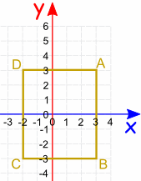
18)
What is the perimeter of rectangle ABCD?
A) 22 B) 20 C) 24 D) 30

19) Write 4⁵ as repeated multiplication.
A) 4x4x4x4x4 B) 5x5x5x5 C) 4x4x4x4 D) 4x5
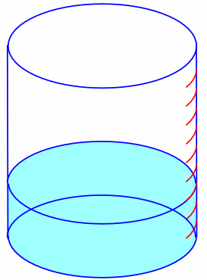
20)
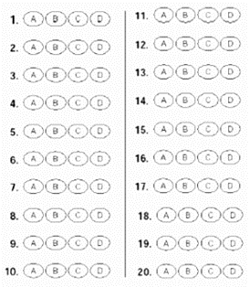
When the water tank is full to the top, it holds 1,000 liters.
How many liters are in the tank now?
A) 300 B) 250 C) 400 D) 350

