MATHS PLAN

COUNTRY: Turkey

SCHOOL : Erzurumlu İbrahim Hakkı Ortaokulu

ACTIVITY NAME: Maths and English-Four basic calculations

MATERIALS: pen,board

ACTIVITY NUMBER: 1

MAKING ACTIVITY:
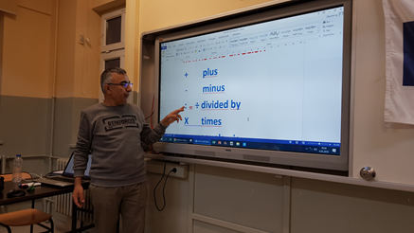
First teacher explains signs of four basic calculations.They do simple
exercises then.
+ plus
- minus
: or ÷ divided by
X times
= equals or is
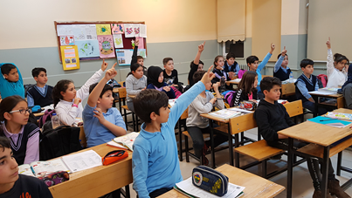
5+2=7
Five plus two equals seven
Addition
Adding two (or more) numbers means to find their sum (or total). The symbol used for addition is '+'.
For example, 5 + 10 = 15
This is read as five plus ten is equal to fifteen or simply, five plus ten is fifteen.
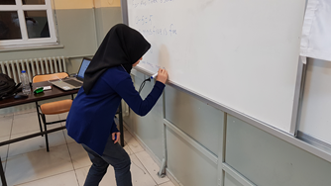
Example:Find the sum of 9 and 8.
Solution:9 + 8 = 17
Subtraction

Subtracting one number from another number is to find the difference between them. The symbol used for subtraction is '–'. This is known as the minus sign.

For example, 17 – 8 = 9

This is read as seventeen take away eight is equal to nine (or seventeen take away eight is nine). Also, we can say that 17 minus 8 is 9.

Example: Subtract 9 from 16.

Solution:16 – 9 = 7

Multiplication

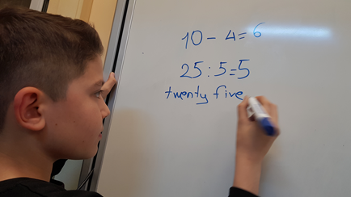
Multiplication means times (or repeated addition). The symbol used for multiplication is '×'.

For example, 7 × 2 = 14
This is read as seven times two is equal to fourteen or simply, seven times two is fourteen.
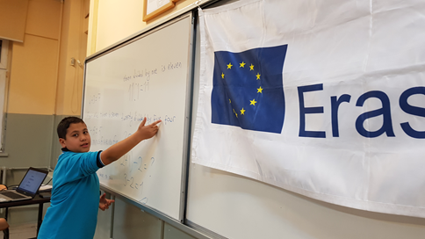
Division
Division 'undoes' multiplication and involves a number called the dividend being 'divided' by another number called the divisor. The symbol used for division is '÷'.
For example: 10:2=5 This is read as ten divided by two is five

