MATHS PLAN

COUNTRY: Turkey

SCHOOL : Erzurumlu İbrahim Hakkı Ortaokulu

ACTIVITY NAME: Maths and Mental Development-Sudoku

MATERIALS: board,sudoku presentation,sample paper

ACTIVITY NUMBER: 4

MAKING ACTIVITY:
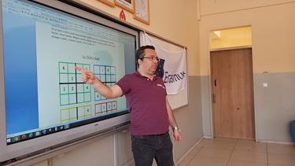
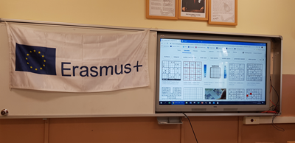
A Sudoku puzzle is defined as a logic-based, number-placement puzzle. The objective is to fill a 9×9 grid with digits in such a way that each column, each row, and each of the nine 3×3 grids that make up the larger 9×9 grid contains all of the digits from 1 to 9. Each Sudoku puzzle begins with some cells filled in. The player uses these seed numbers as a launching point toward finding the unique solution.
It is important to stress the fact that no number from 1 to 9 can be repeated in any row or column (although, the can be repeated along the diagonals).
There are many variations on Sudoku including Mini Sudoku, Cross Sums Sudoku, Killer Sudoku, and Wordoku. We will not cover such variations here.
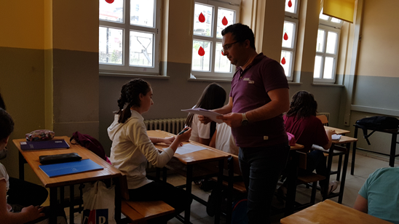
While solving Sudoku puzzles can be significant challenge, the rules for traditional solution finding are quite straight forward:
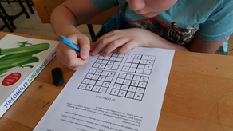
Each row, column, and nonet can contain each number (typically 1 to 9) exactly once.
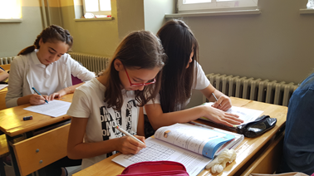
The sum of all numbers in any nonet, row, or column must match the small number printed in its corner. For traditional Sudoku puzzles featuring the numbers 1 to 9, this sum is equal to 45.
This is an important point to review as it isn’t uncommon for inexperienced players to get frustrated and to abandon the techniques we will lay out below. Don’t do it! In order to solve Sudoku puzzles reliably, you must be disciplined, focused, and patient.

