MATHS PLAN

COUNTRY: Turkey

SCHOOL : Erzurumlu İbrahim Hakkı Ortaokulu

ACTIVITY NAME: Maths and Art-Drawing a picture

MATERIALS: A model picture,ruler,protractor,compass, pencils,coloring pencils,crayons,etc

ACTIVITY NUMBER: 1

MAKING ACTIVITY:
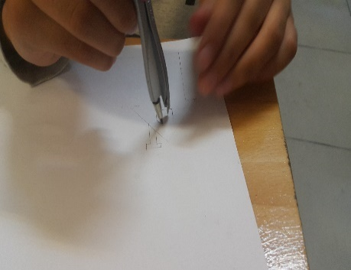
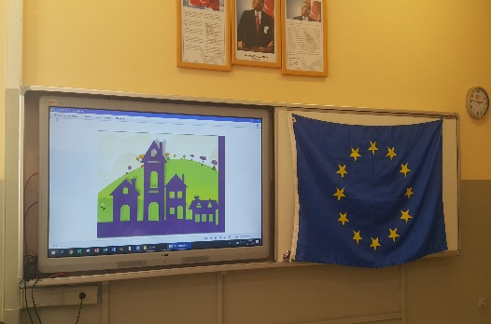
First,pupils will be informed about the activity they are going to make.There will be a picture on the board that pupils can see easily.They will use their rulers,protractor and compasses.After drawing they will color their drawings.
