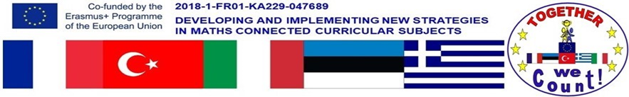

Short Term Joint Staff training events – Ploermel FRANCE – January 27th – February 2nd

We went through the list of tasks and responsibilities to make sure we all knew what to do and also to clarify a few items to make sure we all understood the same thing.
- Each school will have a person who will act as the main contact to communicate within the partnership.
- Greece has created our Twinspace on Etwwinning.
- They have also prepared the project song
- Italy has prepared the project LOGO and Motto
- They have also prepared the Maths Tests
- Estonia will prepare teh surveys after each mobilities
- Turkey will prepare a DVD about our different school systems
- France has prepared the language tests
- After each mobility the hosting country will prepare a e-book and an e-video
We made some changes to the initial project we submitted last year:
- Because Portugal withdraw from the project we have decide to share qthe work they should have done (calendars 2019 – 2020)
- We will work on the videos we should have prepared for the Portuguese mobility (Maths and Social studies and Maths and Drama)
- We have decided not to set up a website as our work will be published on Etwining.
  - The Greek team created our Twinspace and they have also created a Google account hence we also have a Youtube Channel where all our productions will be downloaded.
  - All our work will also be downloaded onto our schools wwebsites
We tried and improved our use of ICT
- We exchanged and explained how to use Etwinning.
- We also went through the procedure to download videos on our Google Drive and Youtube
Our work
- We watched the videos we had all prepared for our first mobility: Maths and Art – Maths and Sport
- The conclusion was that thoough they were all different we all achieved the goal we had set.
- We made sure we all knew what to do for the next mobility.
Mobilities
- We exchanged and decided on the dates and number of pupils and teachers for the future mobilities.
- Because Portugal will not take part in the project, we have decided to use the budget allocated to the trip to Portugal to add more pupils and more teachers to the other mobilities.
- Because some of the schools involved in the project are very small we exchanged about accomodation for the pupils during the mobilities:
  - Should our pupils stay in hotels or host families?
  - We finally decided that pupils shoould stay in host families as one of the aims of the projects is to discover, experience and share a new culture, a new way of life and also it is the best way to communicate.
Exchange of good practice
- We visited the school and watched our talent show
- Teachers met and exchanged with French teachers
- Teachers took part in the French lessons
- We met with Mr Stéphane GOURAUD, Head of all the Catholic Schools in Morbihan.
Culture
- We visited Ploërmel, the old city center and the Astronomical Clock
- We met the Mayor and the Deputy Mayor in charge of Education
- We visited Rennes (capital city of Brittany) and Vannes (capital city of Morbihan)
- We visited the St Armel’s Church.
- We discovered Le Mont Saint Michel, St Malo, Pontivy and Josselin.
Next Meeting will be held in Ankara, Turkey from April 8th to 12th. We have to prepare 2 vidoes related to Maths in English and 2 videos related to Maths and Mental Development.

