MATHS PLAN

COUNTRY: Turkey

SCHOOL : Erzurumlu İbrahim Hakkı Ortaokulu

ACTIVITY NAME: Local time

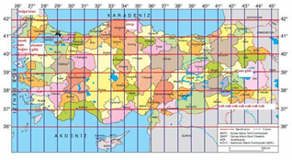
MATERIALS: a map showing meridians

ACTIVITY NUMBER: 4

MAKING ACTIVITY:
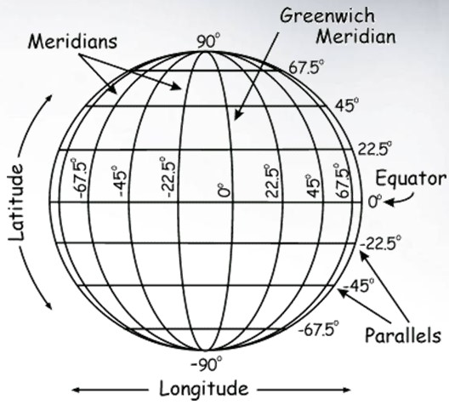
First of all,you see 360 meridians ,lines from pole to pole.180 meridians are in the east and 180 meridians are in the West of Greenwich Meridian.
To calculate the local time we follow the following items:
* We find the meridian difference between two points.
*The calculated meridian difference is multiplied by 4 minutes.Because in a day,in 24 hours, 360 meridians pass opposite the sun.So 24 hours or 1440 minutes is divided by 360 then we get 4.
*If the difference is higher than 60 min,we convert the time into hours.If it is smaller,it is written as it is.
*because the Earth rotates from west to east,local time in the east is higher than the local time in the west.Therefore when it is asked the local time in the east,the calculated time difference is added.If the place is in the west, it is subtracted.If the places are in the same meridian,the local time will be the same.
Example: What’s the local time for the city on the 40◦
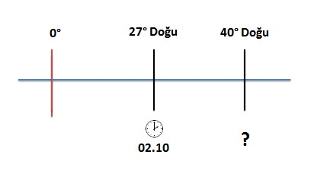

The difference is
40-27=13 meridians this means 13X4=52 mins.
So local time is ;
02.10+52mins=03.02
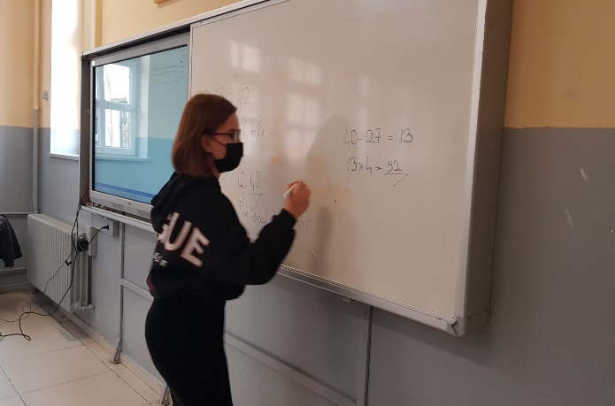
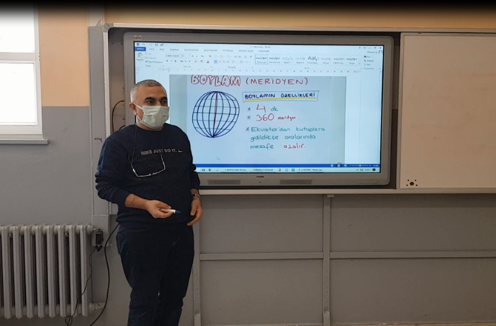
PHOTOS:

