MATHS PLAN

COUNTRY: Turkey

SCHOOL : Erzurumlu İbrahim Hakkı Ortaokulu

ACTIVITY NAME: Abacus calculation
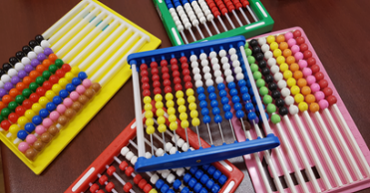
MATERIALS: 1 abacus

ACTIVITY NUMBER: 1

MAKING ACTIVITY:
One of the pupils read the history of abacus:
Developed in China in 2400 BC, abacus spread from Crete and Mycenaean regions to Europe and America, thanks to overseas traders. Abacus is the first calculator known to have moving parts. Although the development of the Arabic numbers and the concept of zero with the help of abacus goes back in history, it is still used in daily trade in different parts of the world and especially in order to improve the mathematical intelligence of children of preschool age.
In Abacus, which is the ancestor of modern calculators and computers, the aim is to add, subtract, multiply and divide the 4 main mathematical operations. Abacus, the invention of the Babylonians, has been of great importance in trade for centuries. The basis of the abacus is based on Crete and Mycenaean, and almost all of the first abacus examples also feature examples of the Crete and Mycenaean ornamentation art.
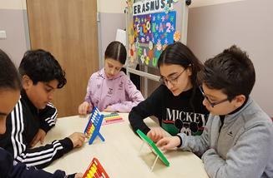
Then teacher showed the following videos about addition and subtraction
After those activities teacher and pupils worked together.

PHOTOS:
