MATHS PLAN

COUNTRY: Turkey

SCHOOL : Erzurumlu İbrahim Hakkı Ortaokulu

ACTIVITY NUMBER: 1

ACTIVITY NAME: Count Down

MATERIALS: Colorful papers,board marker

MAKING ACTIVITY:
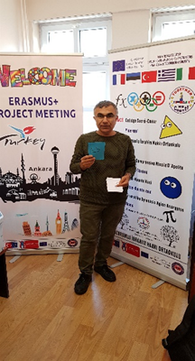
This game is a simple at home version of the TV favourite and can be played with any number of players.
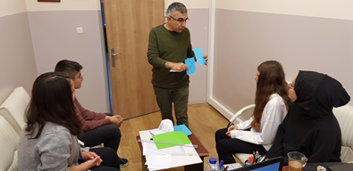
Step 1: Set out 4 large number cards (25, 50, 75 and 100) face down and mixed up.
Step 2: Do the same with the 1 – 10 cards, making sure you have at least 2 cards for each number.
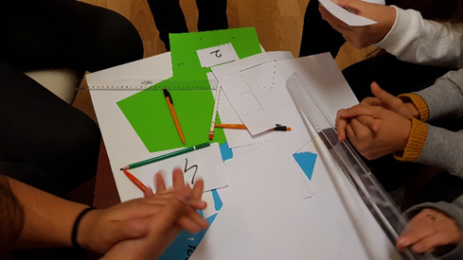
Step 3: Players take it in turns to select one of the big number cards or one of the small number cards, until there are 6 cards laid out all together.
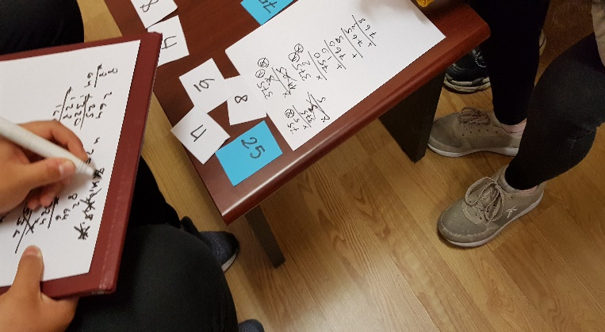
Step 4: Someone who is playing the game needs to generate a 3-digit number. This can be by throwing a dice, or selecting cards from a pile of 0 to 9 cards.
Step 5: Once the number has been generated, turn over the six cards and players have to try and get to that total using any of the six number cards and any of the four operations.
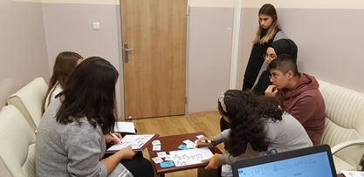
Each card can only be used once and the winner is the first person to reach the total, or the player who is closest after a set length of time.
The game can be adapted for younger children, by choosing the numbers on the cards carefully and having them aiming to reach a 2-digit number, rather than a 3-digit number.

