MATHS PLAN

COUNTRY: Turkey

SCHOOL : Erzurumlu İbrahim Hakkı Ortaokulu

ACTIVITY NAME: Maths and Sports-Hembsball
MATERIALS: Hemsball set

ACTIVITY NUMBER: 3

MAKING ACTIVITY:
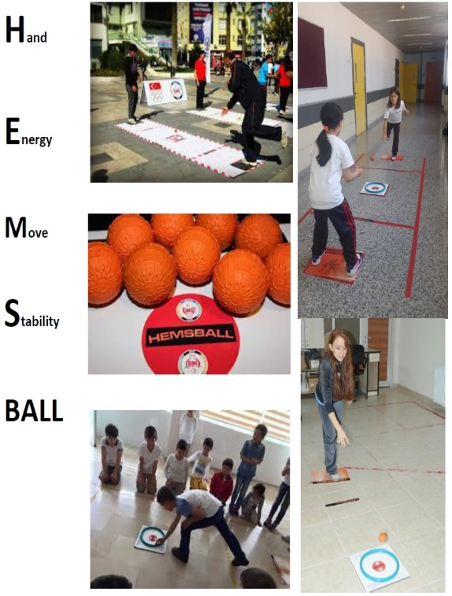
Hemsball is a fun and entertaining new sport that can be played by people of all ages. It can be played easily in both outdoor and indoor areas. While playing Hemsball it is important to have good hand-eye coordination, a high level of focus and concentration in order to be able to catch the ball and serve it. The name of the sport, as shown below, was derived from the first letters of the combination of the performance that is portrayed during the game.
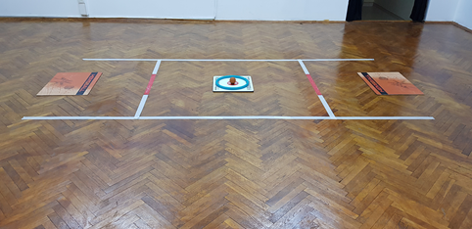
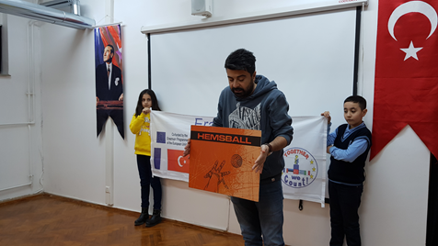
The objective of the game is to throw the Hemsball into the Hemsball hoop that is on the Hemsball target board on the floor, without hitting the hoop and make it go to the player side and into the “player area” and to prevent the rivals from achieving the same goal. While sending the ball into the Game and “player’s” area they may catch the ball in any way including on the plates where they are stepping.
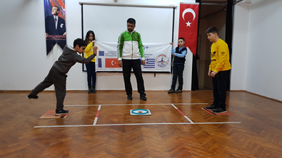
The ball is put into play with a draw in which the loser serves. The player who serves will throw the ball at the hoop to send it to the rival side. The counting will continue until a ball touches inside the hoop, goes out or a player makes a mistake. The player who wins a point gets to serve.
FOCUSING REFLEX BALANCE CONCENTRATION COORDINATION
PHOTOS:
