MATHS PLAN

COUNTRY: Turkey

SCHOOL : Erzurumlu İbrahim Hakkı Ortaokulu

ACTIVITY NAME: Maths and Mental Development-Calcudoku

MATERIALS: board,calcudoku presentation,sample paper

ACTIVITY NUMBER: 3

MAKING ACTIVITY:
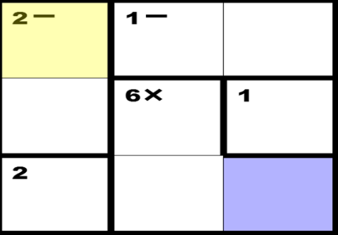

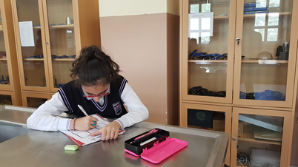
1- Calcudoku is arithmetic and logic puzzle similar to Sudoku
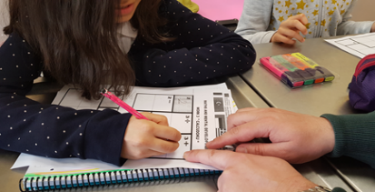
2- Fill the grid so that each row and column only have one of each available number

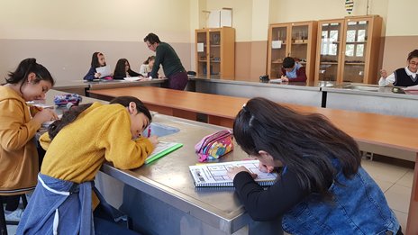
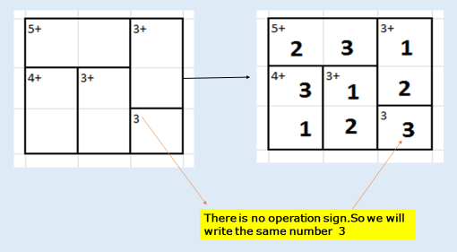
3- You can’t use same number more than once a row or a column
