MATHS PLAN

COUNTRY: Turkey

SCHOOL : Erzurumlu İbrahim Hakkı Ortaokulu

ACTIVITY NAME: Maths and English-Four basic calculations

MATERIALS: pencil,board

ACTIVITY NUMBER: 1

MAKING ACTIVITY:
The four basic mathematical operations are:
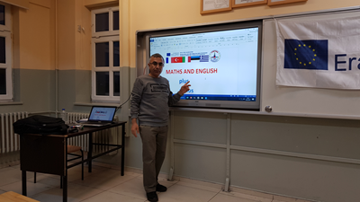
Addition, subtraction, multiplication and division
Addition
Adding two (or more) numbers means to find their sum (or total). The symbol used for addition is '+'.
For example, 5 + 10 = 15
This is read as five plus ten is equal to fifteen or simply, five plus ten is fifteen.
Example 1;
Find the sum of 9 and 8.
Solution:
9 + 8 = 17

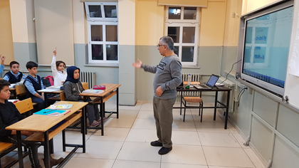
Subtraction
Subtracting one number from another number is to find the difference between them. The symbol used for subtraction is '–'. This is known as the minus sign.
For example, 17 – 8 = 9
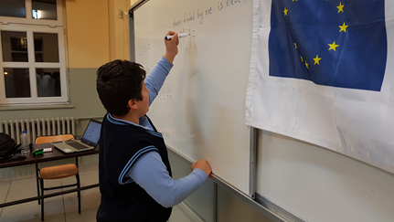
This is read as seventeen minus eight is equal to nine.Also, we can say that 17 minus 8 is 9.
Example 3
Subtract 9 from 16.
Solution: 16 – 9 = 7

Multiplication
Multiplication means times (or repeated addition). The symbol used for multiplication is '×'.
For example, 7 × 2 = 14
This is read as seven times two is equal to fourteen or simply, seven times two is fourteen.
Division
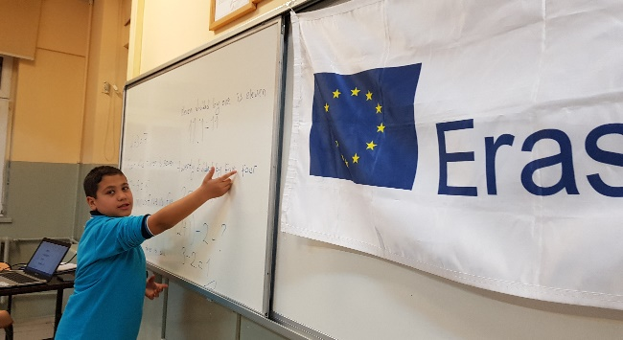
The symbol used for division is “ : “ or “ / “
How can we read the following division?
12/4=3
Twelve divided by four is three
Or
Twelve divided by four equals to three

