MATHS PLAN

COUNTRY: Turkey

SCHOOL : Erzurumlu İbrahim Hakkı Ortaokulu

ACTIVITY NUMBER: 4

ACTIVITY NAME: pattern blockc

MATERIALS: cardboards,ruler,pencil,different colors of self adhesive EVAs

MAKING ACTIVITY:
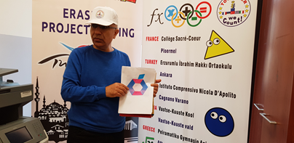
Pupils will draw different patterns from different mathematical shapes to form a
definite picture on the backside of the EVAs.They will look at ready printed
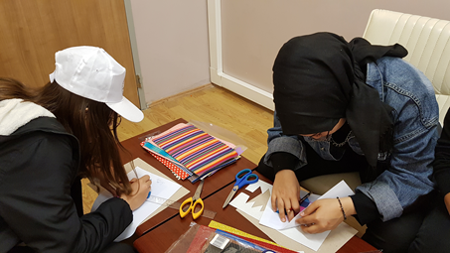
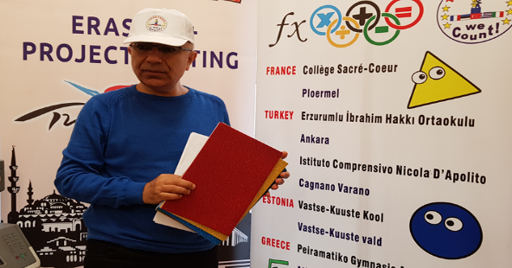
template.Then they will stick shapes on the cardboards.

