MATHS PLAN

COUNTRY: Turkey

SCHOOL : Erzurumlu İbrahim Hakkı Ortaokulu

ACTIVITY NAME: Maths and Art-Fibonacci squence

MATERIALS: pencil,squared paper,colored pencils,crayons,ruler,compass

ACTIVITY NUMBER: 2

MAKING ACTIVITY:
The Fibonacci Sequence is the series of numbers:
0, 1, 1, 2, 3, 5, 8, 13, 21, 34, ...
The next number is found by adding up the two numbers before it.
The 2 is found by adding the two numbers before it (1+1)
The 3 is found by adding the two numbers before it (1+2),
And the 5 is (2+3),
and so on!
Example: the next number in the sequence above is 21+34 = 55

It is that simple!

Here is a longer list:

0, 1, 1, 2, 3, 5, 8, 13, 21, 34, 55, 89, 144, 233, 377, 610, 987, 1597, 2584, 4181, 6765, 10946, 17711, 28657, 46368, 75025, 121393, 196418, 317811, ...
Makes A Spiral
When we make squares with those widths, we get a nice spiral
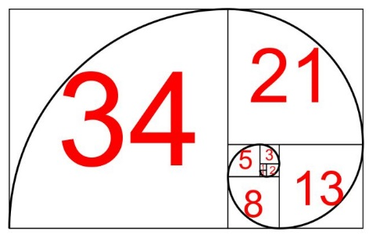
.

Do you see how the squares fit neatly together?
For example 5 and 8 make 13, 8 and 13 make 21, and so on
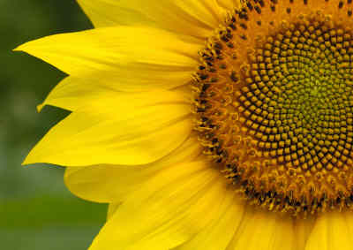

PHOTOS:
