MATHS PLAN

COUNTRY: Turkey

SCHOOL : Erzurumlu İbrahim Hakkı Ortaokulu

ACTIVITY NAME: Origami

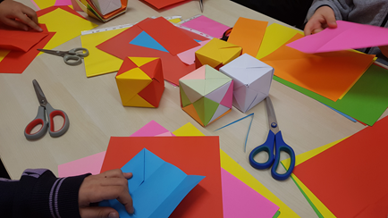
MATERIALS: Colorful papers and scissors

ACTIVITY NUMBER:2

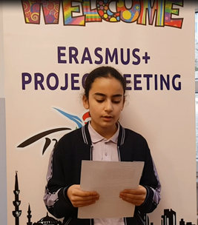
MAKING ACTIVITY:
One of the students read the history of origami:
ORIGAMI is a combination of the words "oru" meaning Japanese folding and "kami", which means paper. It is known as "The Art of Paper Folding." Origami art emerged with the arrival of the paper. As it is a visual, auditory and kinesthetic activity, it is still accepted as an educational tool for learning today. Usually, they are geometric shapes created by simply folding the pieces of square paper without cutting and using glue.
Is there a relationship between math and Origami?
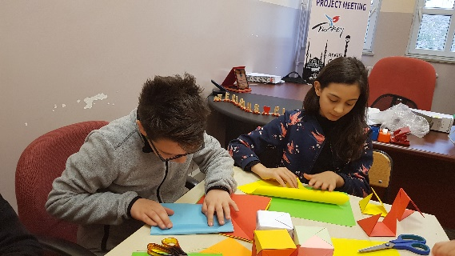
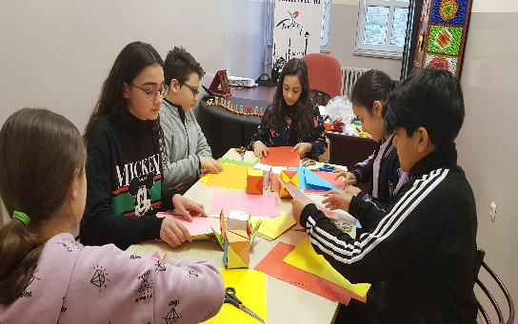
In fact, every fold in Origami is a form of geometry. At least in your childhood, you have simply tried to make an airplane, a ship, a salt shaker model. How we fold the paper, what shapes we use to create the shape are all mathematics and geometry. For example, we use triangular, rectangular and square geometry shapes even when making a small cat. Origami art has also been developed and diversified over time. Today, this has very rich and fascinating shapes.
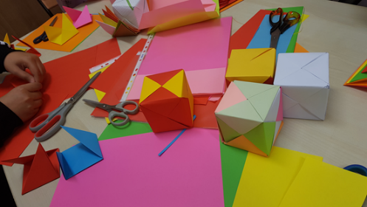
Also, when folding paper in Origamide, it naturally appears in many geometric shapes and concepts. Some of these are square, rectangular, right triangle, diagonal, midpoint, beam, area, trapezoid, middle strut, Pythagorean theorem, geometry and algebra.Therefore, it is an important method that can be used in understanding shapes in geometry because of the feature of forming shapes.
Then teacher tells about basic shapes about origami while folding the paper.
Students watch a video about making a cube then they make at the same time.
PHOTOS:
