MATHS PLAN

COUNTRY: Turkey

SCHOOL : Erzurumlu İbrahim Hakkı Ortaokulu

ACTIVITY NUMBER: 3

ACTIVITY NAME: Evil Eye Bead

MATERIALS: Colouful beads,glue,cardboard

MAKING ACTIVITY:
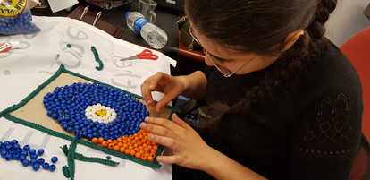
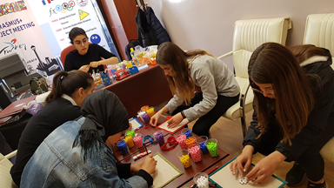
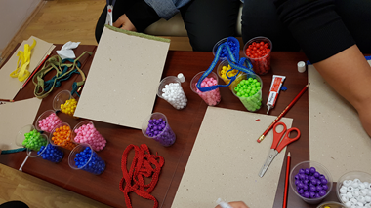
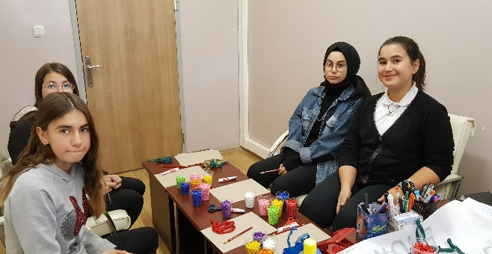
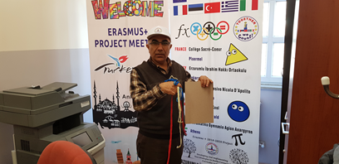
Pupils will draw the evil eye bead then they will stick colorful beads on the cardboards.In drawings,they will use mathematical shapes.

