MATHS PLAN

COUNTRY: Turkey

SCHOOL : Erzurumlu İbrahim Hakkı Ortaokulu

ACTIVITY NUMBER: 2

ACTIVITY NAME: Playing darts

MATERIALS: Darts

MAKING ACTIVITY:
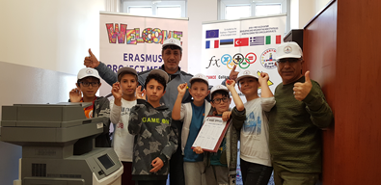
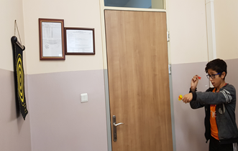
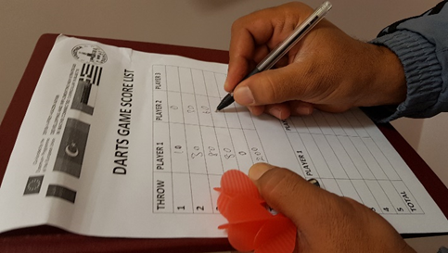
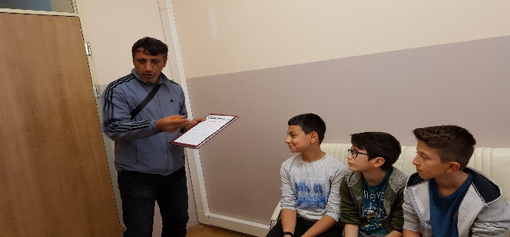
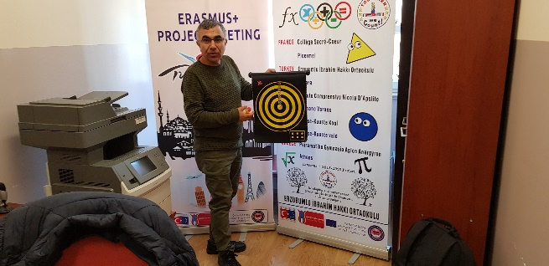
The players throw three darts and set the number for the round.The aim is to get highest point in total.Darts can be played in groups.

