This article is about the ancient Jordanian city of Petra. For other uses, see Petra (disambiguation).
Petra
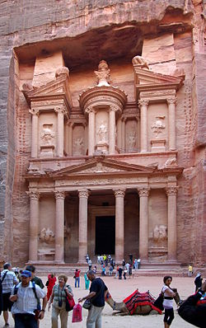
Tourists in front of Al Khazneh (The Treasury) at Petra
Location | Ma'an Governorate, Jordan
Coordinates | 30°19′43″N 35°26′31″ECoordinates: 30°19′43″N 35°26′31″E
Area | 264 square kilometres (102 sq mi)^{[1]}
Elevation | 810 m (2,657 ft)
Built | possibly as early as 5th century BC ^{[2]}
Visitors | 596,602 (in 2014)
Governing body
Website | www.visitpetra.jo
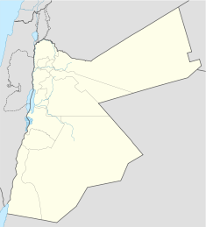
Location of Petra
Raqmu in Jordan
UNESCO World Heritage Site
Criteria | Cultural: i, iii, iv
Referenc | 326
Inscriptio | 1985 (9th Session)
Petra (Arabic البتراء, Al-Batraʾ; Ancient Greek:), originally known as Raqmu, is an historical and archaeological city in southern Jordan. Petra lies on the slope of Jabal Al-Madbah in a basin among the mountains which form the eastern flank of Arabah valley that run from the Dead Sea to the Gulf of Aqaba.^{[3]} It was established possibly as early as the 4th century BC as the capital city of the Nabataean kingdom. The Nabataea’s were nomadic Arabs who invested in Petra's proximity to the trade routes by establishing it as a major regional trading hub.^{[4]}
The trading business gained the Nabataea’s considerable revenue, and Petra became the focus of their wealth. The earliest recorded historical reference to the city was when an envious Greek dynasty attempted to ransack the city in 312 BC. The Nabataea’s were, unlike their enemies, accustomed to living in the barren deserts, and were able to repel attacks by utilizing the area's mountainous terrain. They were particularly skillful in harvesting rainwater, agriculture and stone carving. The kingdom's capital continued to flourish until the 1st century AD when its famous Al-Khazneh facade was constructed, and its population peaked at an estimated 20,000 inhabitants.
Encroaching troops of the Roman Empire in 106 AD forced the Nabataea’s to surrender. The Romans annexed and renamed the kingdom to Arabia Petraea. Petra's importance declined as sea trade routes emerged, and after a 363 earthquake destroyed many structures. The Byzantine period witnessed the construction of several Christian churches. By 700, the city became an abandoned place where only a handful of nomads grazed goats. It remained unknown to Europeans until it was rediscovered in 1812 by Swiss explorer Johann Ludwig Burckhardt, who had read the historical descriptions of Petra and concluded that "there is no other ruin between the extremities of the Dead sea and Red Sea, of sufficient importance to answer to that city".^{[5]}
The city is famous for its rock-cut architecture and water conduit system. Another name for Petra is the Rose City due to the color of the stone out of which it is carved.^{[6]} It has been a UNESCO World Heritage Site since 1985. UNESCO has described it as "one of the most precious cultural properties of man's cultural heritage".^{[7]} Petra is a symbol of Jordan, as well as Jordan's most-visited tourist attraction. Tourist numbers peaked at 1 million in 2010, the following period witnessed a slump due to regional instability. However, tourist numbers have picked up recently and around 600,000 tourists visited the site in 2017.

MADE BY MY MANGER WALED BANI YUNS
1 AHMAD ABU ZAITOON
2 KHALED RIAD HLAIL TEACHER AMER BANI YUNES
3 MHOMMAD MGASGAS
4 MHOMMAD MUNIR
5 WESAM SALEH

