eTwinning Project Heritage Exchange: 3D Printing 3D Buildings

Portuguese Heritage: project ideas
Within this document you will find some of our famous monuments, to spark 3D modeling and printing ideas. The research was made by the pupils of the 7D class.

Content
Castle of the moors (Sintra) 2
Ponte 25 De Abril 5
Mosteiro da Batalha 6
Mosteiro dos Jerónimos 9
National Pantheon 10
Tower of Belém 12
Roman Temple of Diana 13
Tower of Belém 15

Castle of the moors (Sintra)

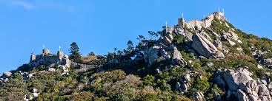

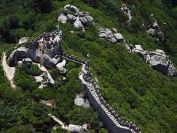

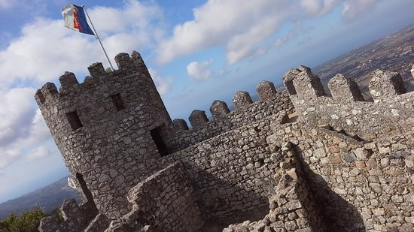

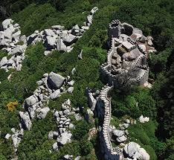

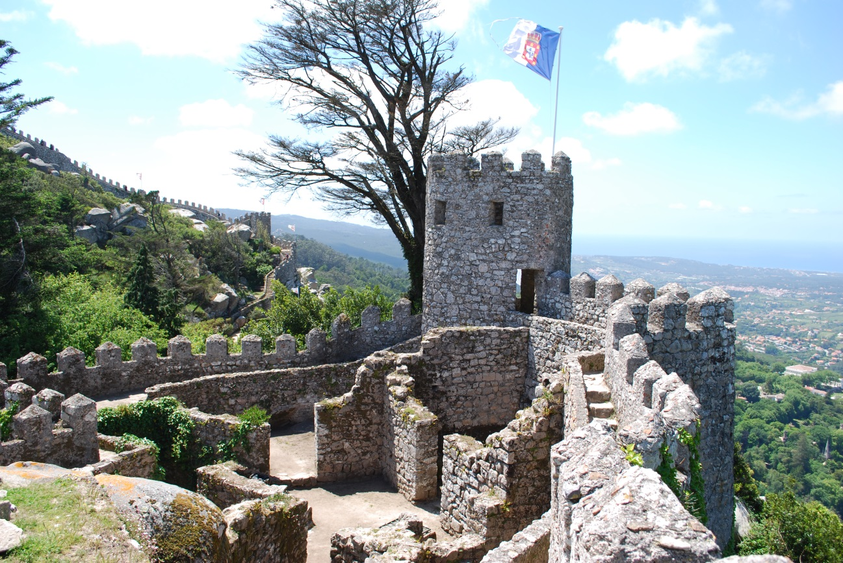
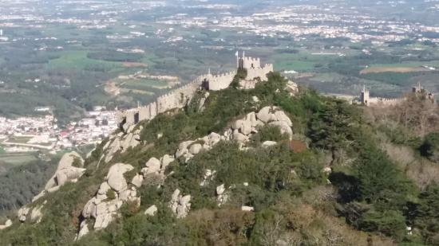

The Castle of the Moors (portuguese castelo dos Mouros) is a hiltop medieval castle located in the central portuguese civil parish of Santa Maria e Sao Miguel , in the municipality of Sintra ,about 25 km northwest of lisbon. Built by the MOORS in the 8th eight and 9th nine centuries, it was an inportant strategic point during the Reconquist , andwas taken by Christian forces after the fall of Lisbon in 1147.It is classified as a NATIONAL MONUMENT, part of the SINTRA CULTURAL LANDSCAPE , a UNESCO WORLD HERITAGE SITE .

Ponte 25 De Abril
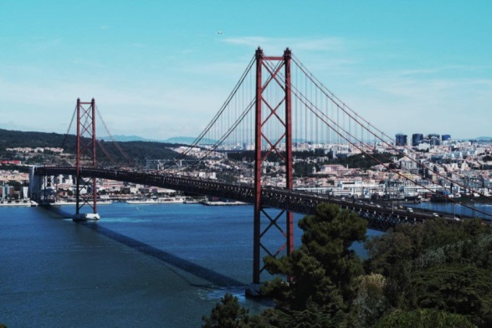
The first idea about the construction of a bridge linking the city of Lisbon to Almada, located on the left bank of the Tagus, dates back to 1876. At that time, the engineer Miguel Pais suggested that its construction be done between Lisbon and Montijo .

Mosteiro da Batalha
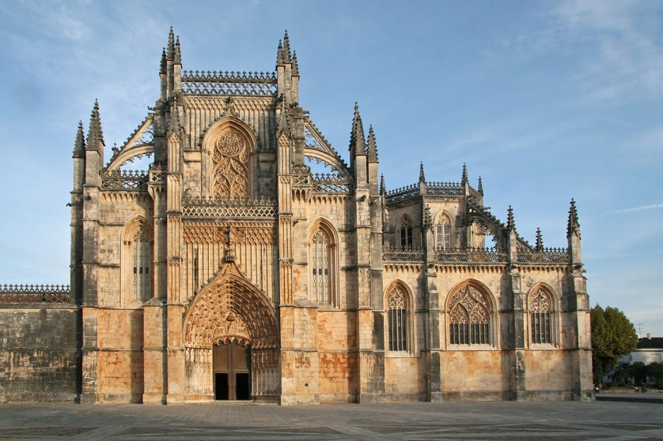
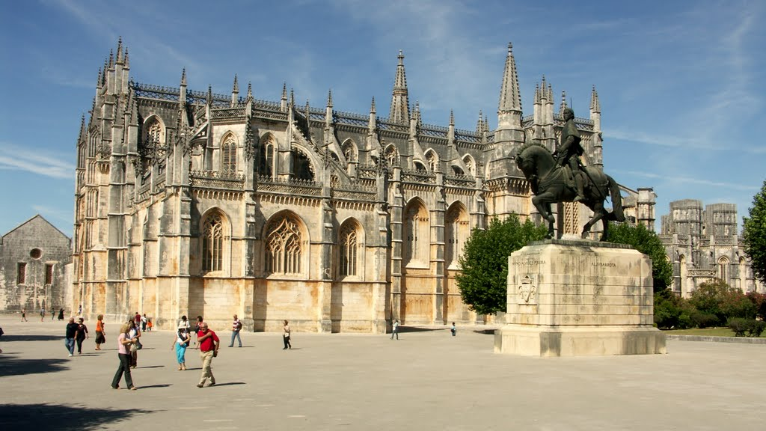
This monument is called Monastery of Batalha, it is a monastery located in the city of Batalha. It was built in 1386 by King João I of Portugal as a thank you to the Virgin Mary for the victory against the Castilians in the battle of Aljubarrota. This monastery of the Order of St. Dominic was built over two centuries until around 1563, during the reign of seven Portuguese kings, although the first Dominicans lived there since 1388. It isan example of Portuguese architecture of Late Gothic or Manueline style, is considered Patrimony, and on July 7, 2007 was elected as one of the Seven Wonders of Portugal.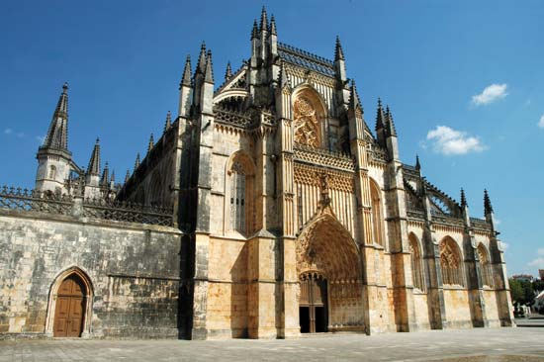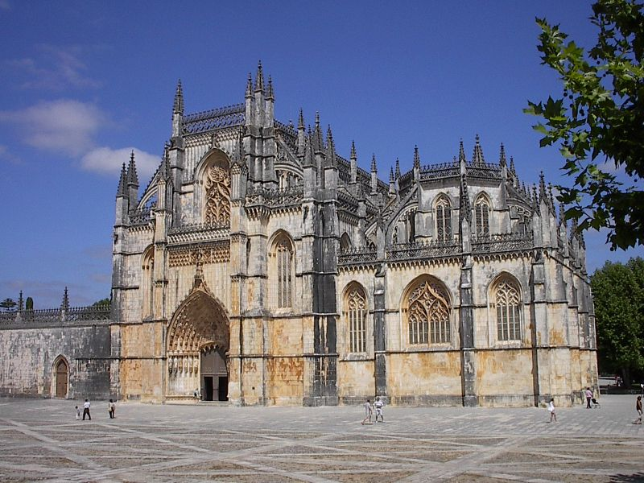

Mosteiro dos Jerónimos
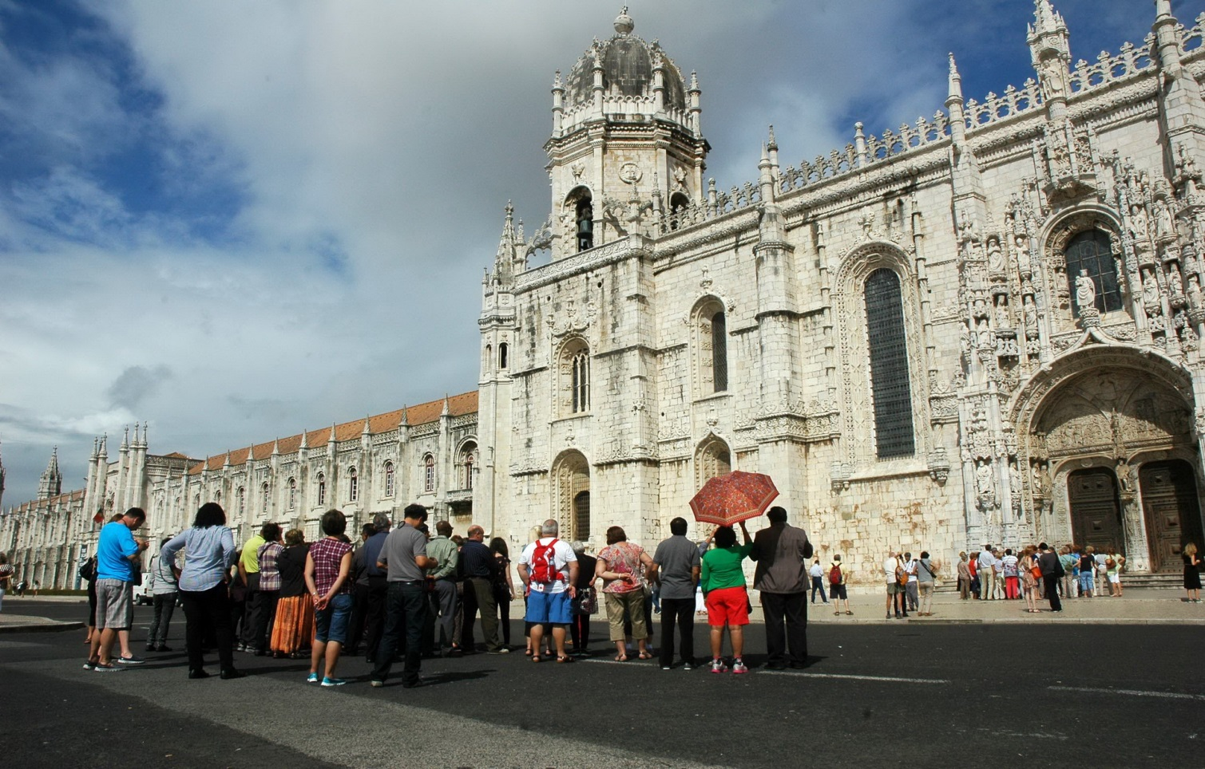
This is Mosteiro dos Jerónimos in Belém/Lisboa.
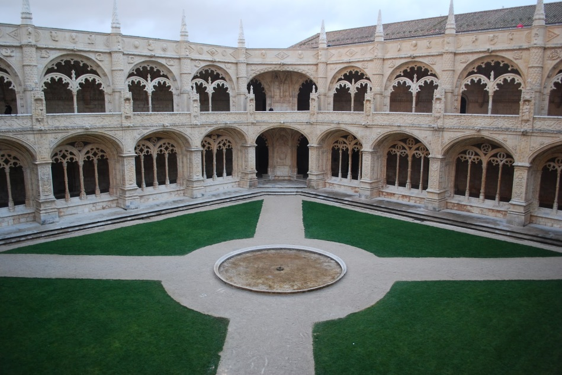
Mosteiros was built in century XVI and currently is a tourist place

National Pantheon
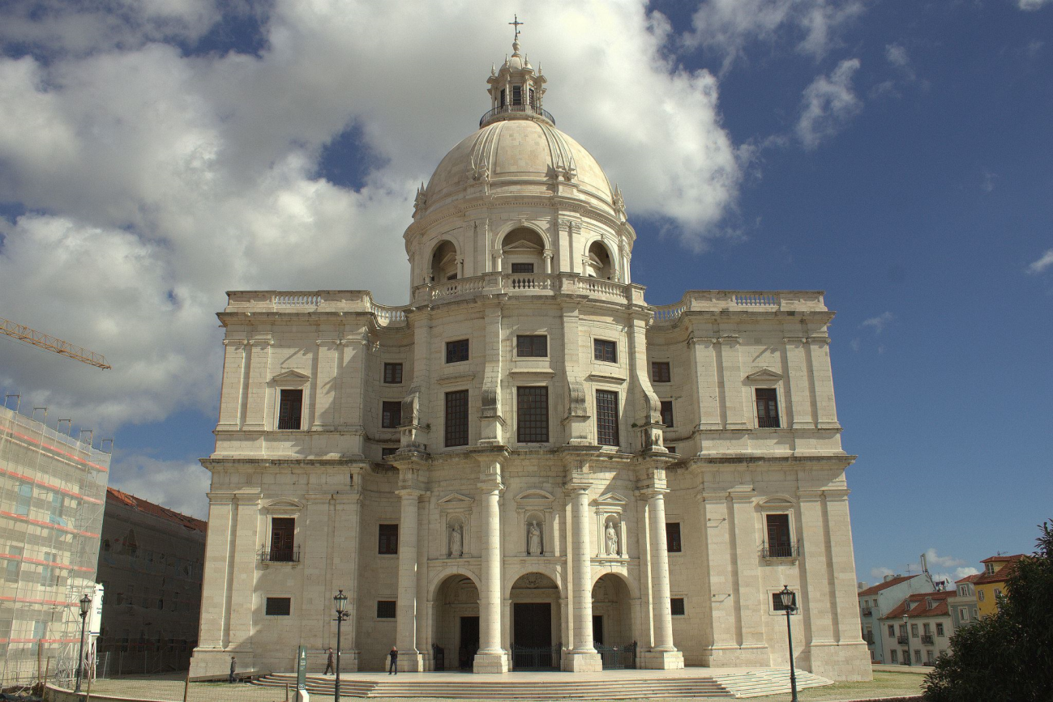
The National Pantheon was founded in the second half of the 20th century. XVI, this is intended to honor and perpetuate the memory of Portuguese citizens who have distinguished themselves by services provided to the country.
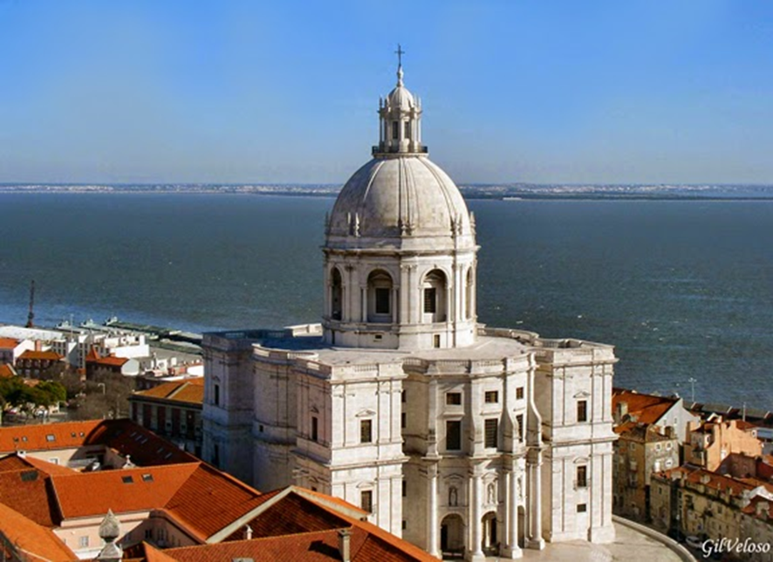
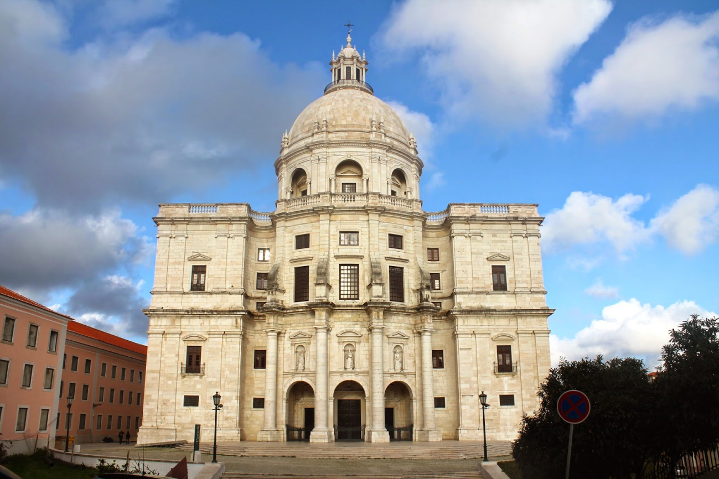

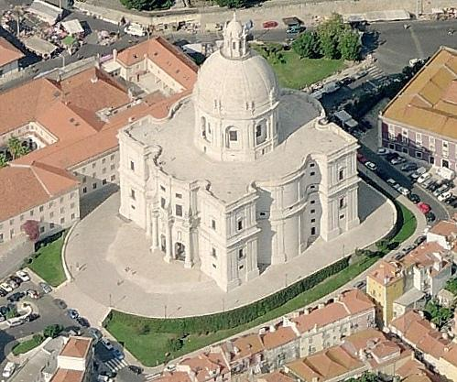

Tower of Belém
São Jorge’s monuments ,is located in Lisbon .it as 1 million visitors its very known in Portugal , it was built in century XVI , it was the most visited monument in Portugal last year and its number 1 in top 7 Portugal monuments.

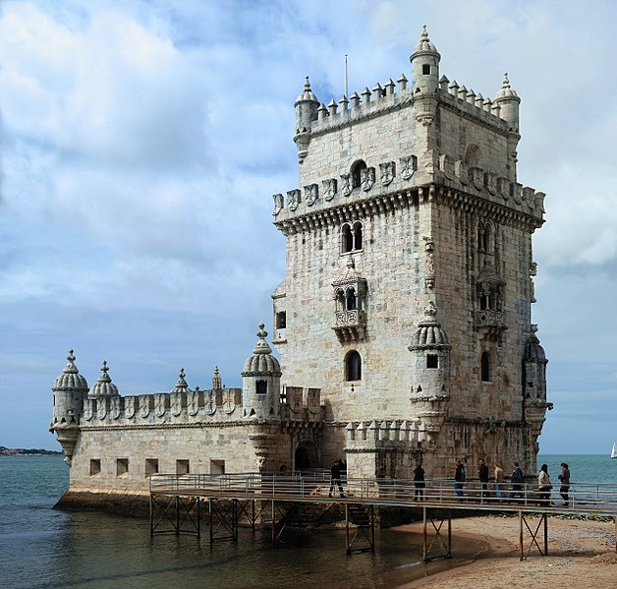
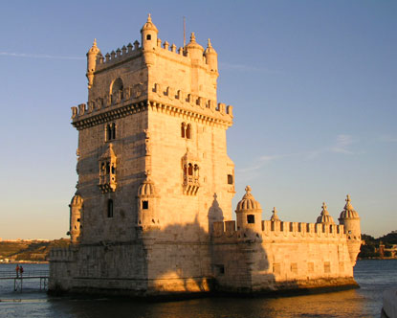
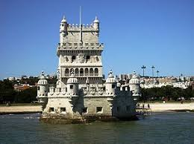
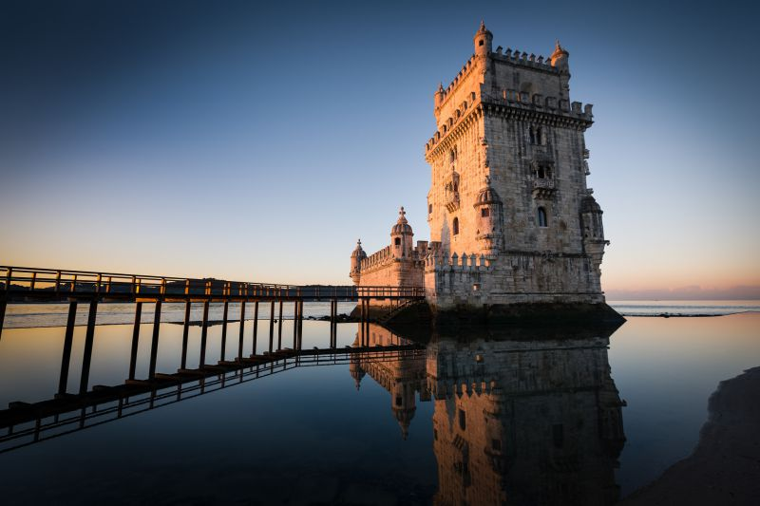

Roman Temple of Diana
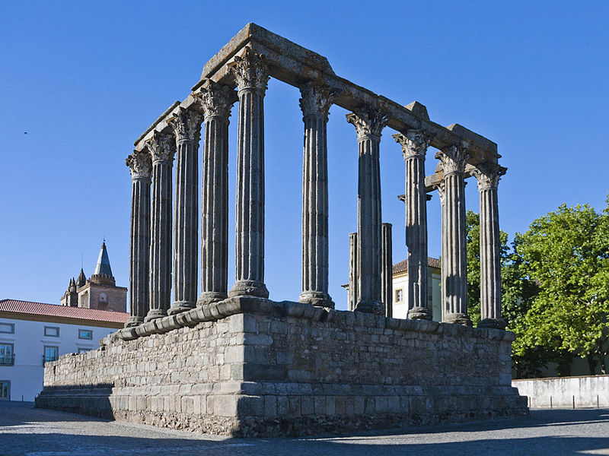
The Roman temple of Évora, erroneously known as Temple of Diana, is located in the city of Évora, in Portugal; is part of the historical center of the city, which was classified as World Heritage by UNESCO. The Roman temple is classified as a National Monument by IGESPAR. It is one of the most famous landmarks of the city, and a symbol of the Roman presence in Portuguese territor.
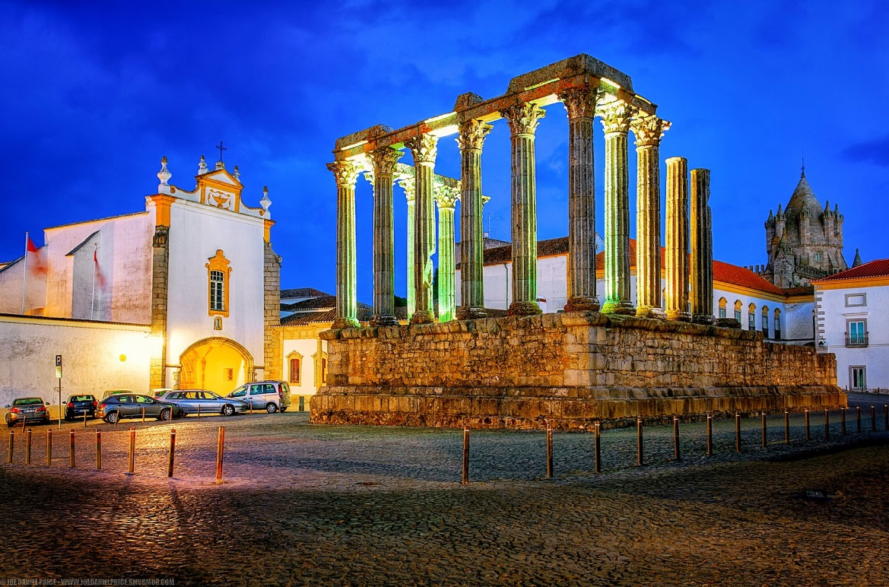

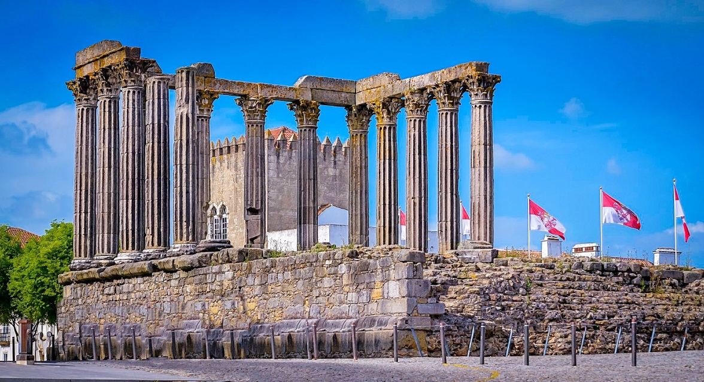

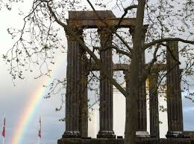

Tower of Belém
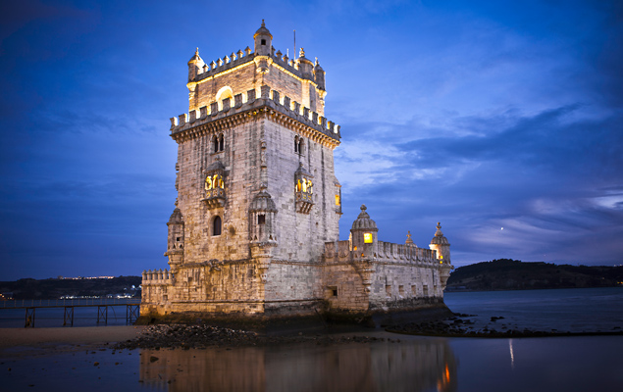

The tower of Belém is a Portuguese monument with more than 500 years that served to protect from enemy attacks and to imprison enemies

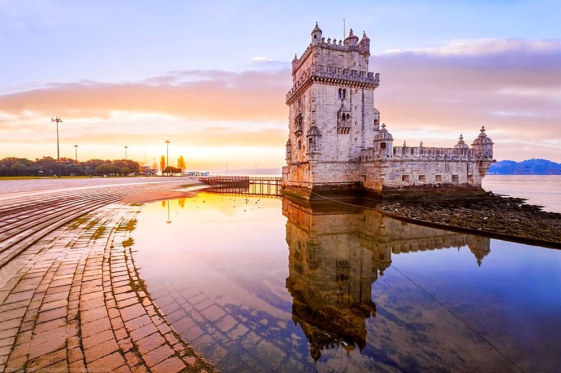
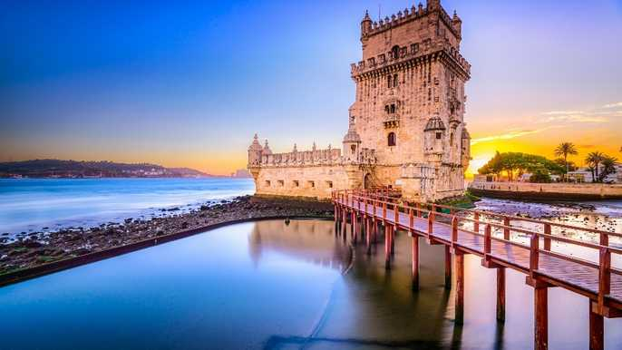

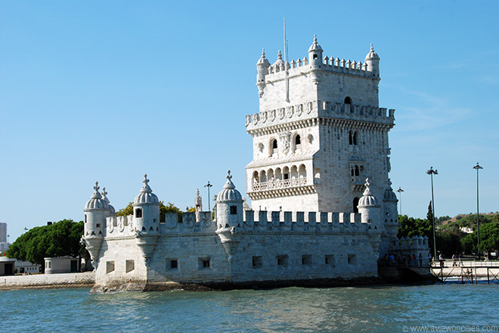
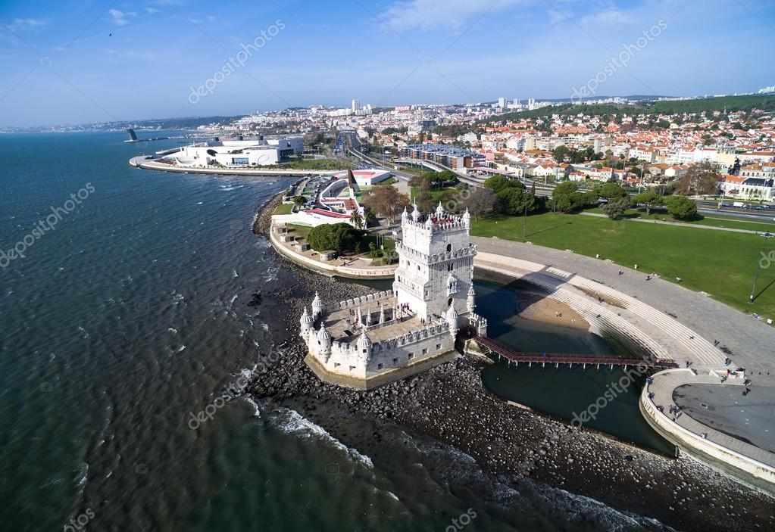

The Belém tower is located in Lisbon

