THE BAR at ISTITUTO Moretti

In the school where I go there isn’t a canteen because we go home for lunch. School ends at 1:20 p.m. from Monday to Saturday. However we have a small bar for the teachers and students, where we all buy our snacks for our school break from 10:55 to 11:05 (ten minutes) every day .
This is the entrance to the bar:
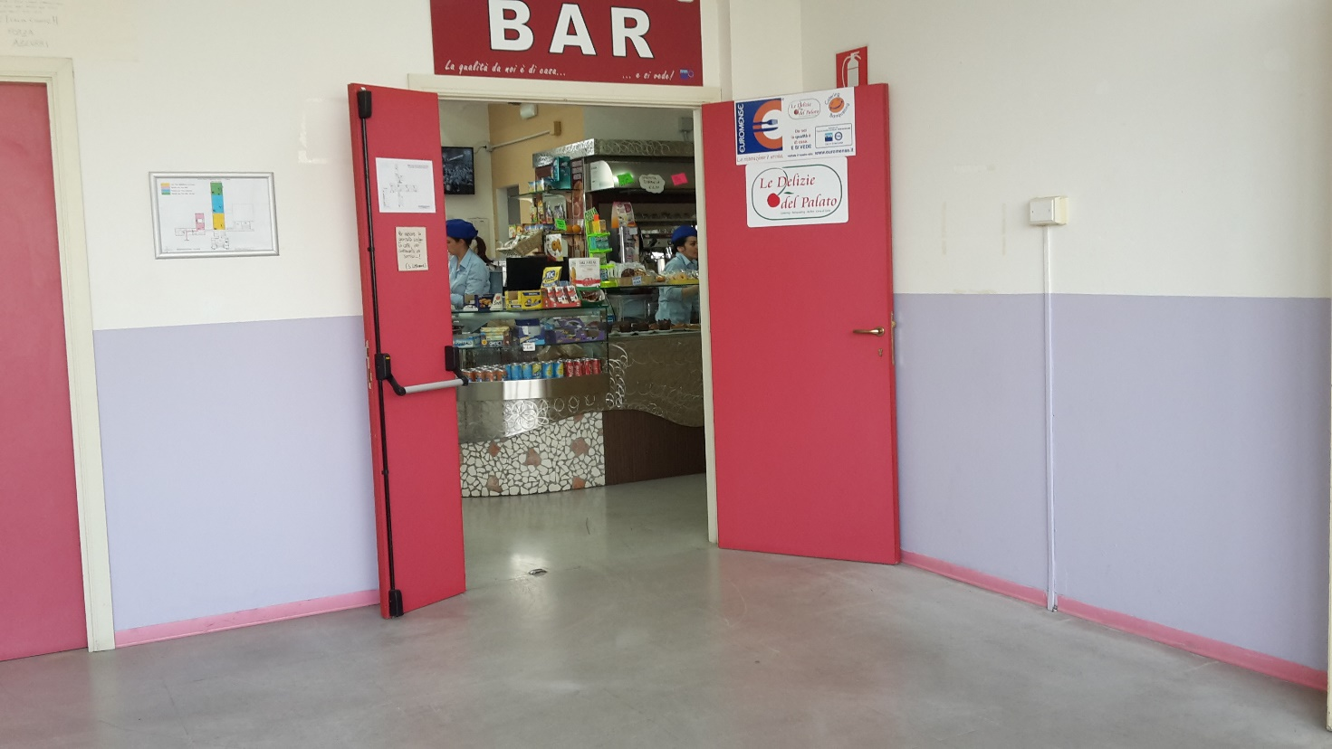
Every morning all the classes of our school compile a list and choose from the products that the bar sells. A school attendant takes the list to the bar and the girls that work there prepare all the food ordered from each class. Ten minutes before the break a student from each class goes to the bar and picks up the food ordered by the students in the class. This is to avoid chaos with hundreds of students that go to buy their snacks during the break.
We can choose from many types of sandwiches and desserts.
In our bar you can have a wonderful breakfast or snack with coffee, cappuccino, tea and all types of drinks, croissants, biscuits, donuts, pastries, ice-cream ham and cheese sandwiches, veal cutlet sandwiches, salami sandwhices, pizza and snacks.