From 9/1 to 13/1 2017
The week menu

Mon | Fish soup
 | 1.Turkey bacon, mixed vegetables, potatoes
 | 2.Pork meat, potatoes
 | Fruit tea, water with lemon
Tue | Cauliflower soup
 | 1. Pie with apples and cream cheese
 | 2. Chilli con carne, bread
 | Fruit tea, water with lemon, cocoa
Wed | Vegetable soup with couscous and lentil
 | 1. Beef meat, potato dumpling
 | 2. Rabbit meat, vegetables, potatoes
 | Fruit tea, water with lemon
Thu | Curry soup
 | 1. Saltwater fish, mashed potatoes
 | 2. „Spring“ chicken salad, pastry
 | Fruit tea, water with lemon
Fri | Tomato soup
 | 1. Chicken meat with cheese, pasta
 | 2. Spanish souffle, tomato salad
 | Fruit tea, water with lemon

School canteen
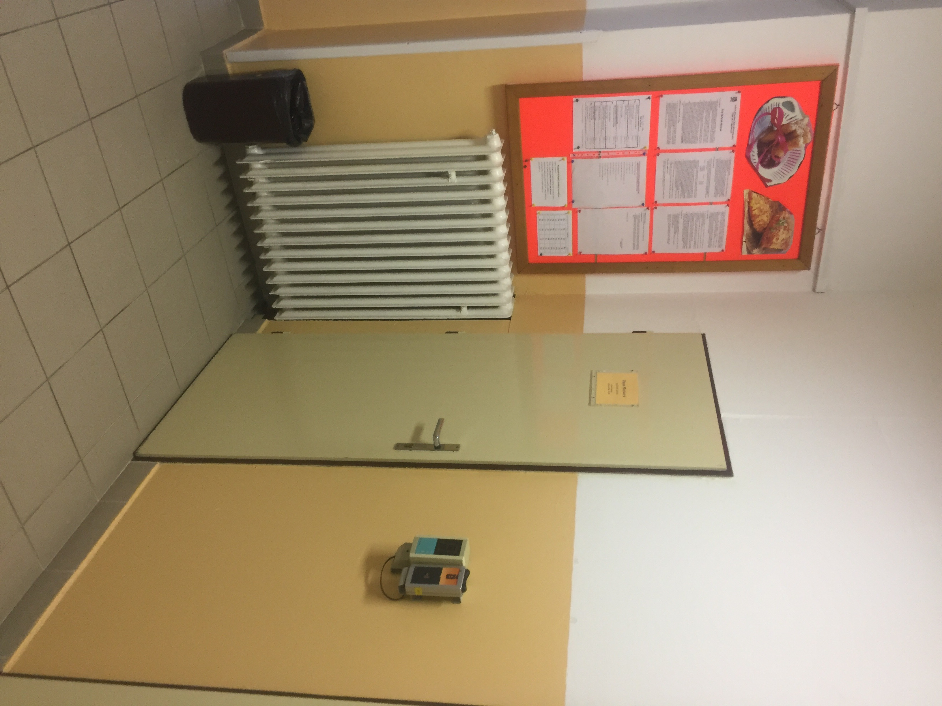
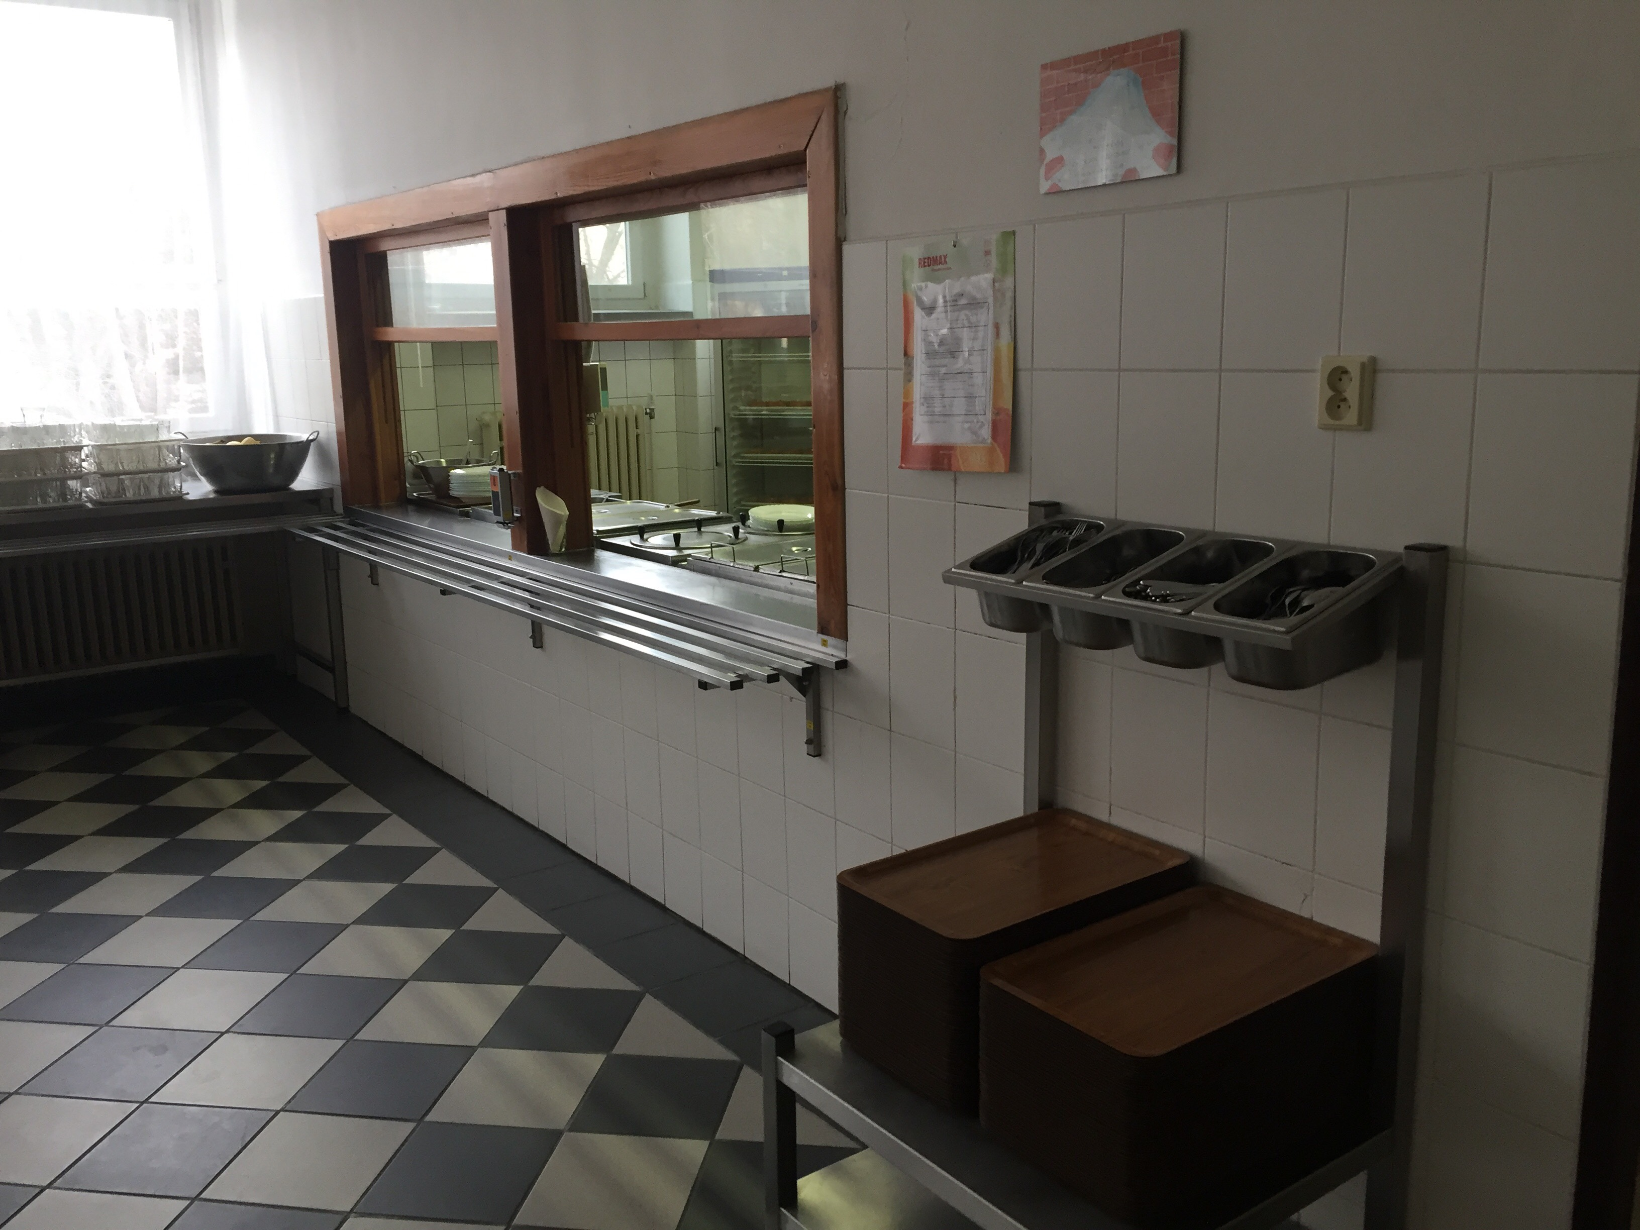Our canteen is very big. It‘s open from Monday to Friday from 11:35 to 14:15. We can choose from two types of food a day before. We can choose food on the internet or by chip. One meal cost 30 Czech Crowns that´s about 1 euro.
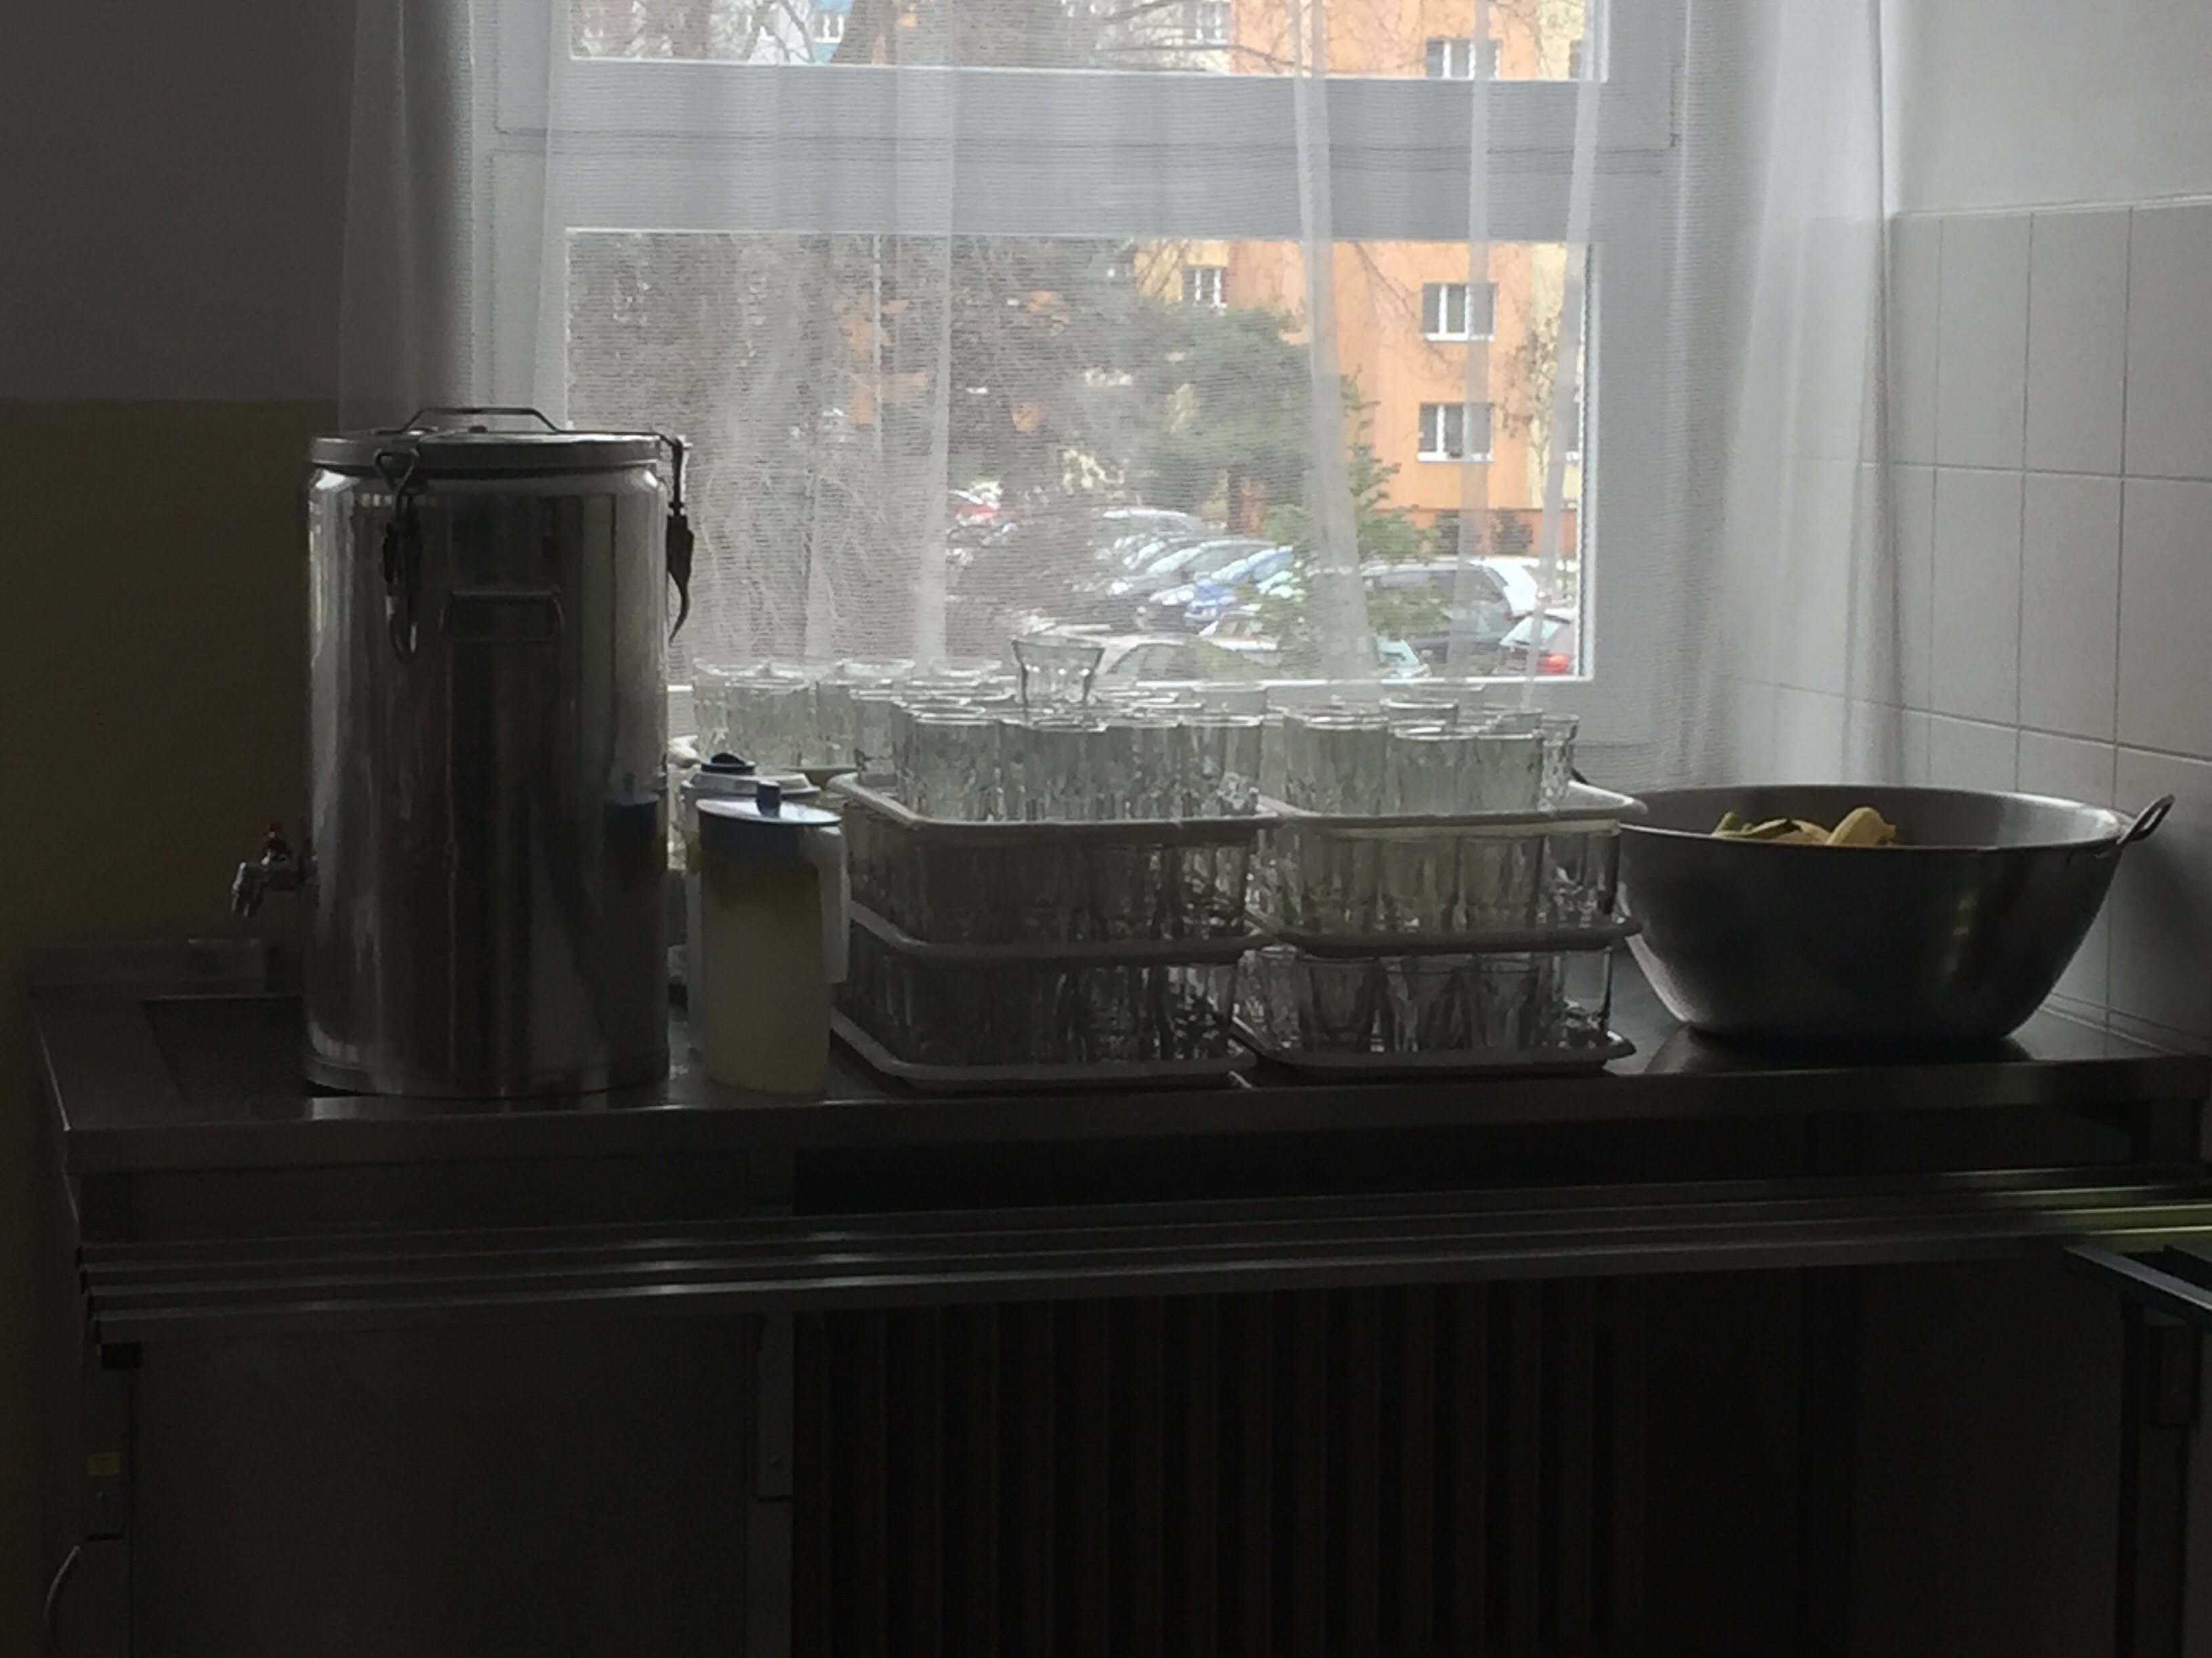We have soup every day. We have got two types of drink: tea or lemon water and sometimes we have got more types of drink: milk, cacao…
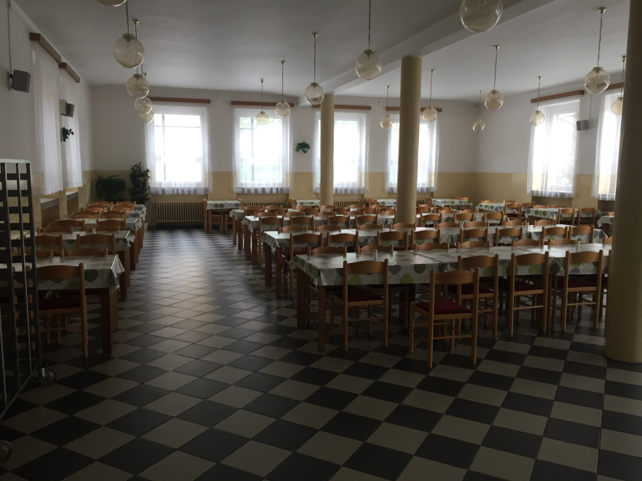There are so many tables. In the canteen can eat about 100 students at same time.
We have a dear cooks.

