School canteen
Information about school canteens
Pupils and teatcher can choose between two kinds of dishes. Everybody have selected dish number 1. for all month. We can choose number two in school canteen by our chip or card and also by on the internet web page: Strava.cz bud you can do it to the previous day to 2:10 PM.
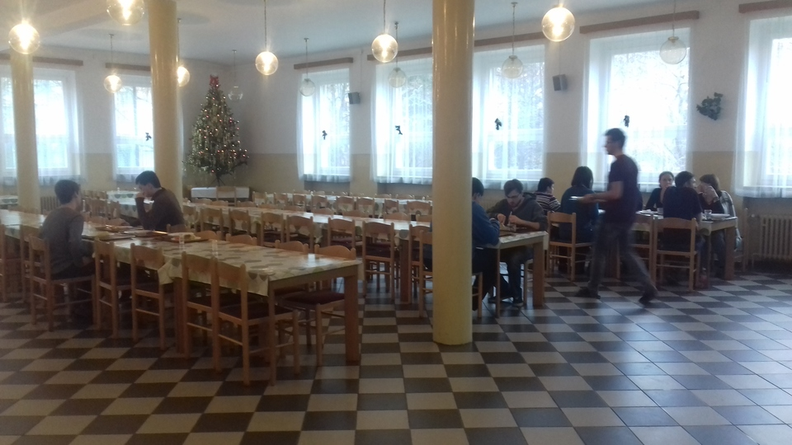
Week : from 9.1. to 13.1.
Monday | soup: | Fish soup
 | 1. meal: | Turkey bacon, mixed vegetables, potatoes
 | 2. meal: | Roll from meat, mashed potatoes with cabbage
 |  | fruit tea, water with lemon
Tuesday | soup: | Cauliflower
 | 1. meal: | Pie with apples and cheese
 | 2. meal: | Chilli con carne, bread
 |  | tea with lemon, water with lemon, cocoa
Wednesday | soup: | Lenticular vegetable couscous
 | 1. meal: | Pieces of meat with sauce, potato dumplings
 | 2. meal: | Rabbit on vegetables, potatoes
 |  | fruit tea, water with lemon
Thursday | soup: | Indian chicken curry
 | 1. meal: | Saltwater fish after the Canadian mashed potatoes
 | 2. meal: | Spring chicken salad, bread
 |  | tea with lemon, water with lemon
Friday | soup: | Tomato with drops
 | 1. meal: | Chicken on a floodplain, pasta
 | 2. meal: | Spinach pie, tomato salad
 |  | fruit tea, water with lemon

