School canteen
We have our own school canteen at school. It´s open from 11:30 am to 14:15 pm. We can choose from two different types of meal, but we must choose it one day before. We can order our lunch on the internet site too.
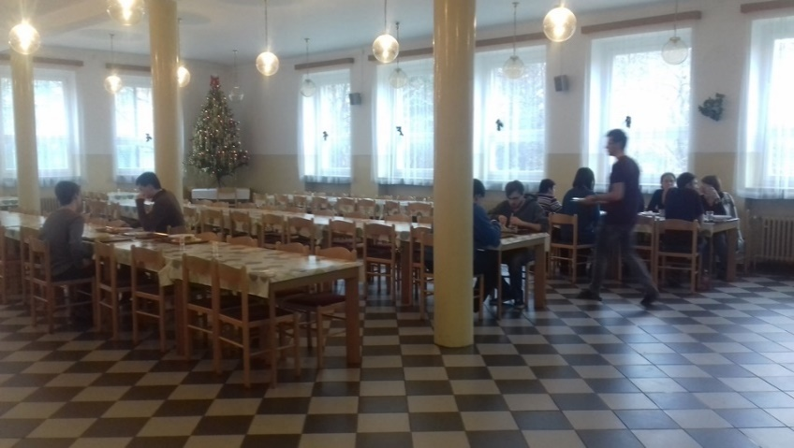

One meal costs 30 Czech crowns (it´s about 1 Euro). We pay it in advice by the monthly payment by card. One meal includes a plate of soup, main course, a cup of tea or milk or lemonade and often some dessert like pie, snack or some fruit.
Our cooks cook a lot of kinds of meal. Except typical Czech meals like “svíčková” (beef sirloin in cream sauce) or “rajská” (beef with tomato sauce) they cook foreign and quite exotic meals too. For example they cook sea fish, Serbian risotto, chilli con carne, tortilla or lasagne.
