13th Primary School of Kalamaria, GREECE
OUR NEWS FROM OCTOBER/NOVEMBER 2016

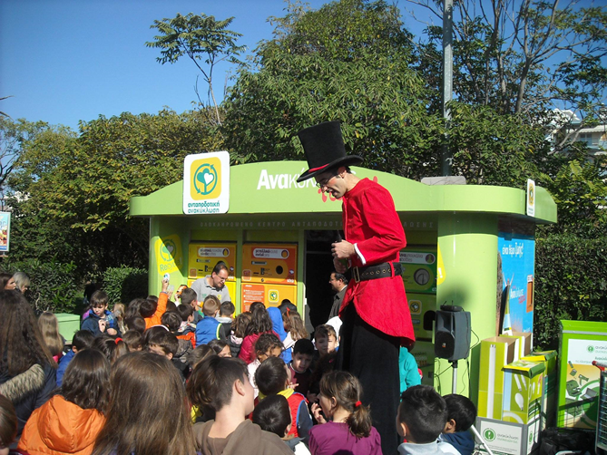

Participation in a Recycling Program
On the 31st of October, 2016 our two classes of 6th Grade took part in a Recycling Festival, organized by a local supermarket in co-operation with a company that rewards the citizens who recycle products, named “Antapodotiki”. This program is being conducted under the auspices of the Greek Archbishop, the Ministry of Education and the organization “Apostoli”.
The target of this action is the promotion and importance of recycling, so as our students know better the meaning of Rewarding Recycling.
Our students managed to gather in a very short time (2 weeks) a huge amount of plastic, aluminum and glass bottles, cans and other kinds of packaging that were finally recycled. Thanks to their grand participation, they won 5 of the 6 most important prizes of the rewarding list; they won- among other schools- 2 tablets, 2 MP4 gadgets and 1 MP3 gadget.
All the children were really excited, as they gained a positive experience from the recycling program and they learned that recycling today is a high priority for our school and for our planet’s future.

.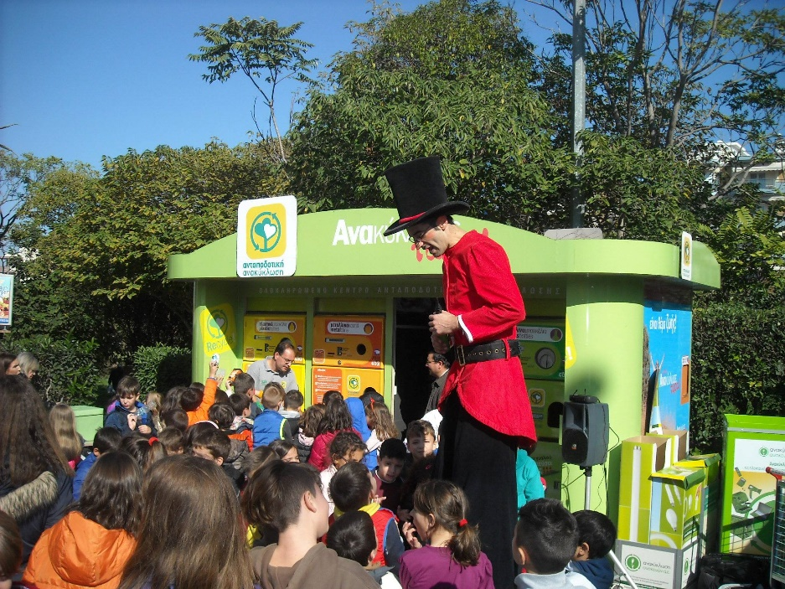

A visit to a famous writer’s Theme Park
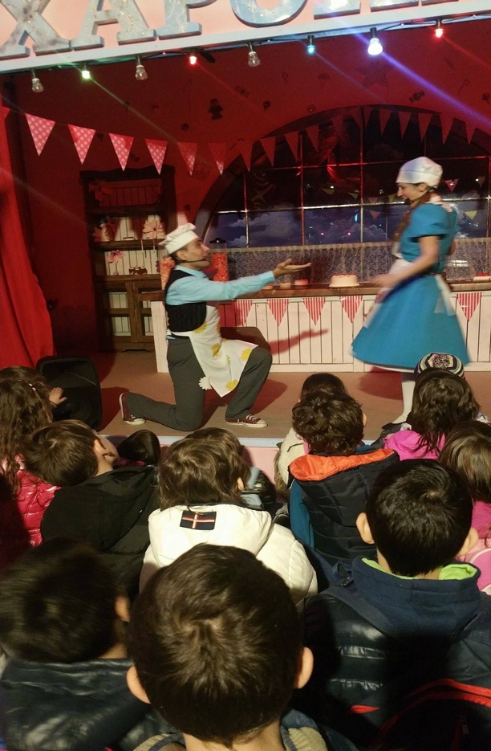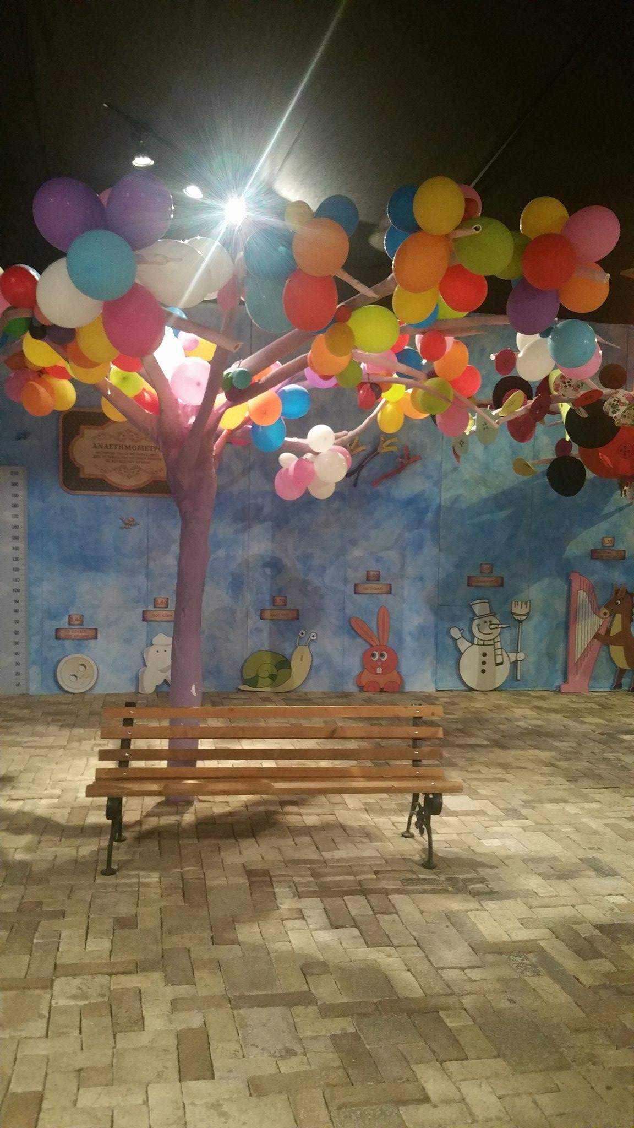

Last week the first classes of our school (A+B Classes) visited the Theme Park of a famous playwright and author, named Eugenios Trivizas. His books have become very popular not only in Greece but worldwide and they are translated in many languages.
The students watched a theatrical performance where the heroes of all its books made their appearance and many famous scenes were performed. The pupils were fascinated by the fairytale-like setting and the successful adaptation of the plays; their favourite heroes of the books came into life and that was a wonderful surprise for them. The whole experience was very positive and all the children were influenced positively so as to continue reading Trivizas’ books.
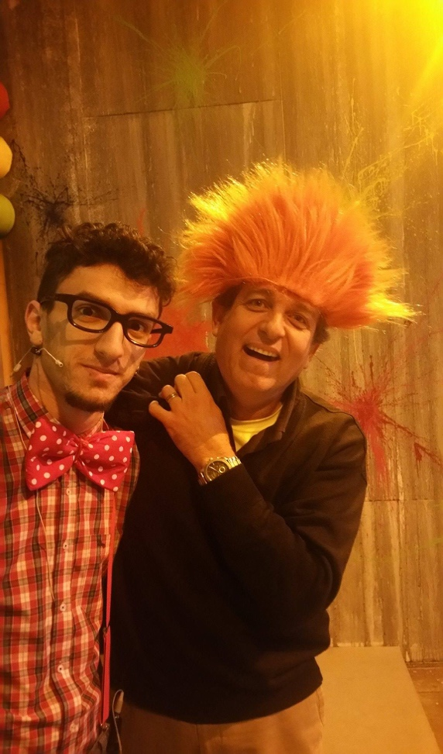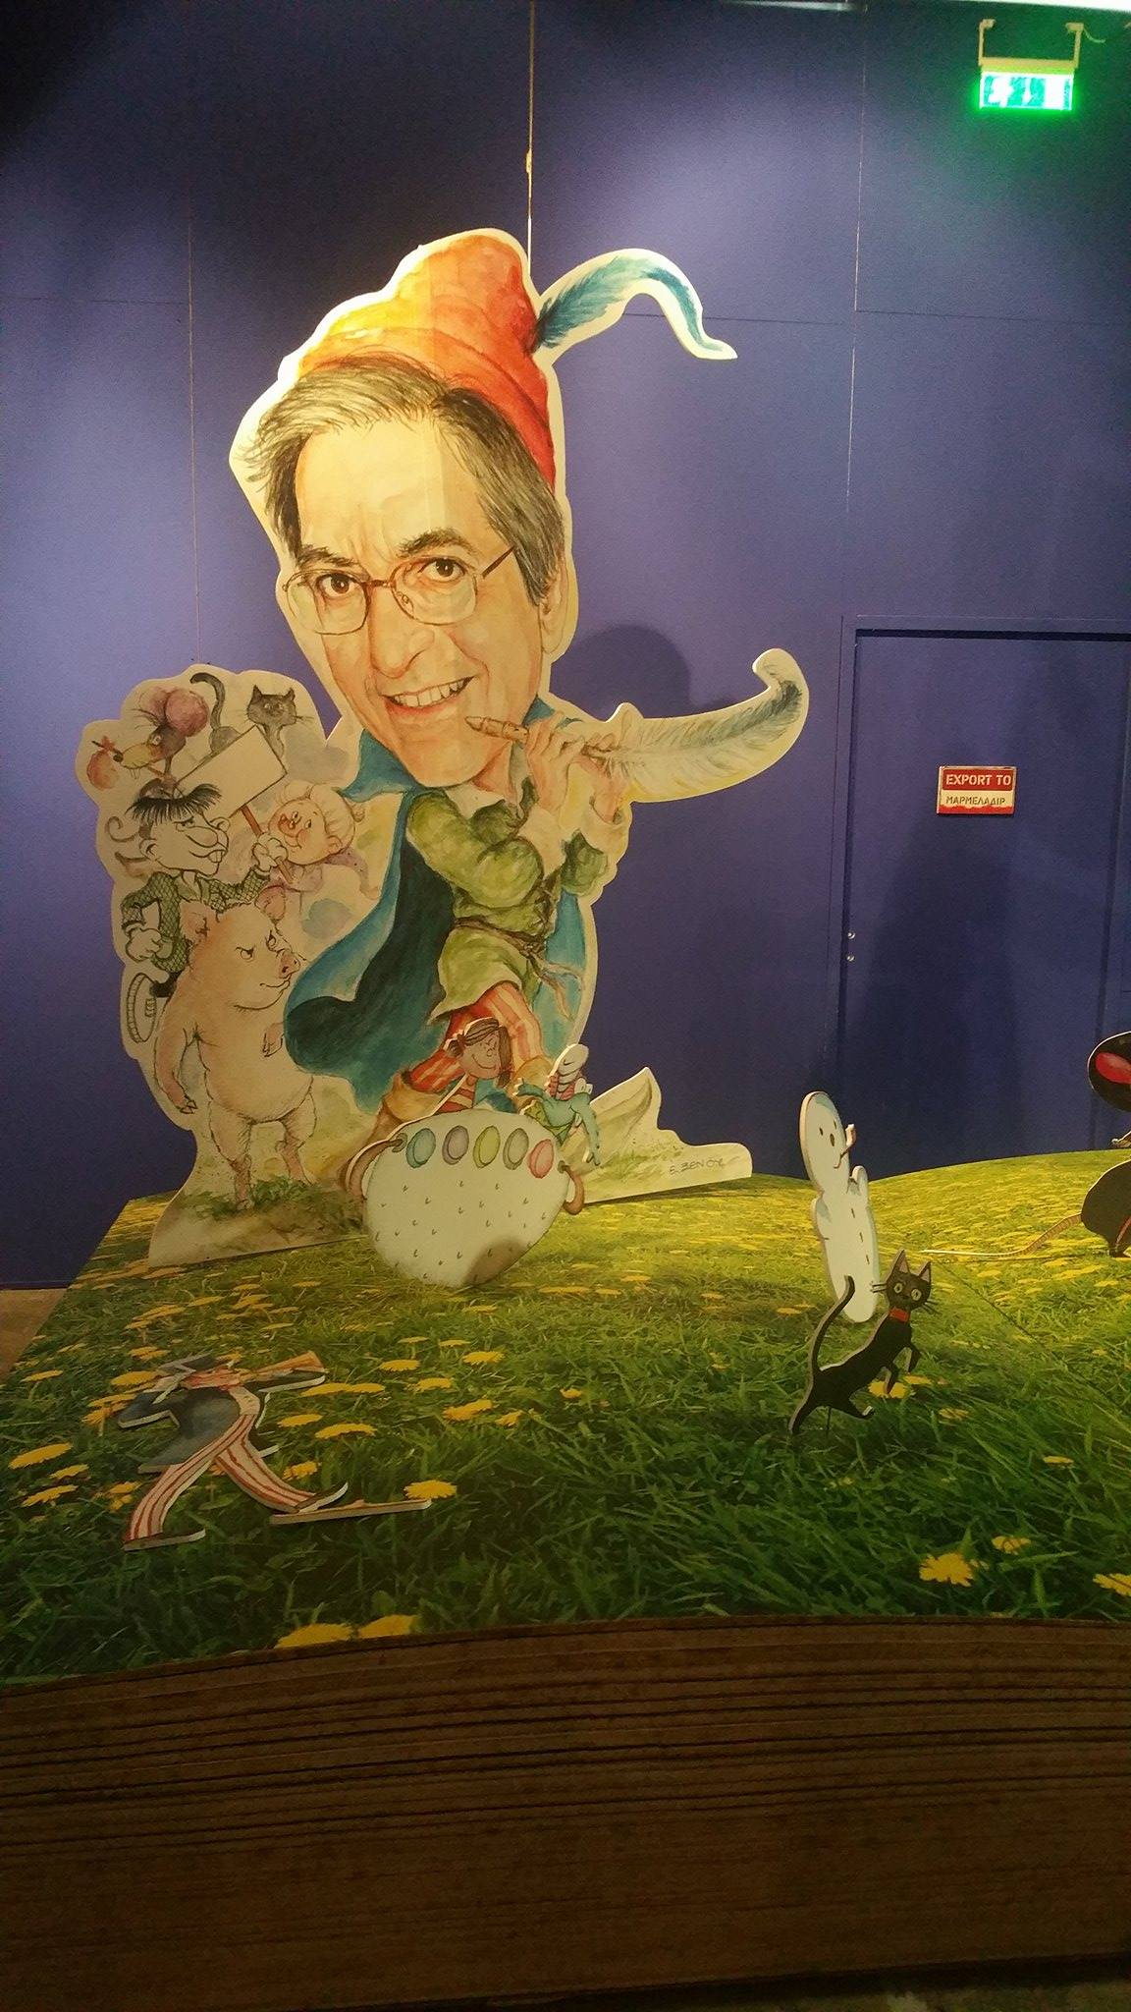

Our daily routine
by students of E Class (5th Grade)
The students of the 5th Grade wrote about their daily routine and look forward to hearing about the daily routine of their partners!
